This service material is provided to make it easy for parishes to incorporate variety in worship. It includes all the content that might appear in a worship folder thus making it unnecessary to retype any content. Musical lines are for the congregation. Listen to the audio sample (at Connect) to hear one example of how this might sound. Other "sounds" are possible depending on what instruments are used and whether choir or soloists sings. See additional notes at the end.

Gathering Rite: Lead Us to Your Light
The opening hymns and songs of Christian worship mean to "gather" individual Christians into a worshiping assembly. What the traditional service does with hymns, canticles, and opening liturgy, this Advent gathering rite does with contemporary song and responses.
Lead Us to your light
The cantor/choir introduces the refrain. Then the congregation repeats the refrain and sings it again as indicated.
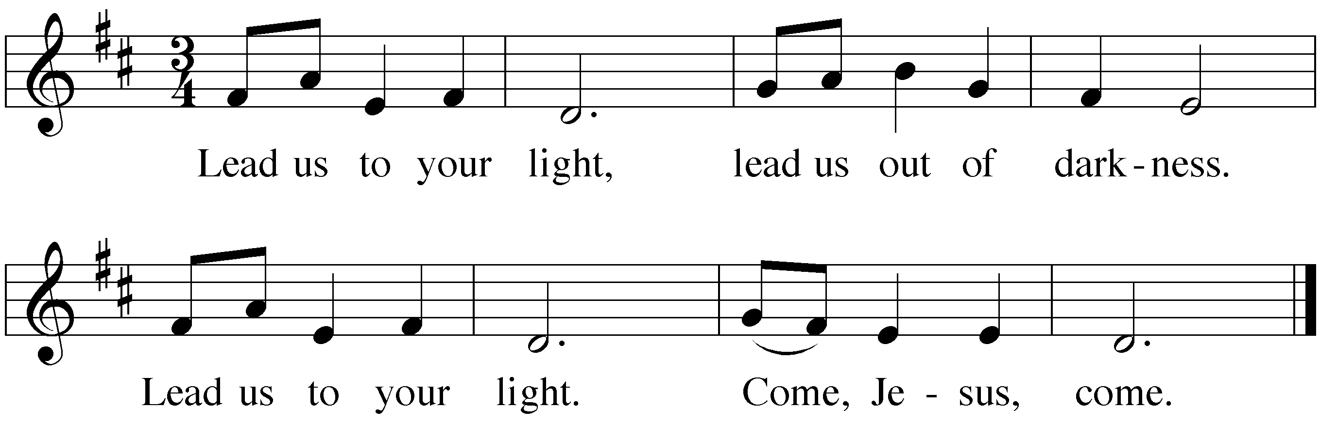
Lord, we await your coming to our world;
Bring us the gift of salvation. R
Lord, you are hope and healing for our world;
Come, now, and bring us your good news. R
Come, O come, O come, Emmanuel;
Come with us on earth here to dwell. R
Rouse us from sleep, wake us from our slumber;
Banish the darkness of night. R
Child of the light and love beyond all telling,
Fill our hearts with wonder and praise. R

Greeting
M: In the name of the Father and of the Son and of the Holy Spirit.
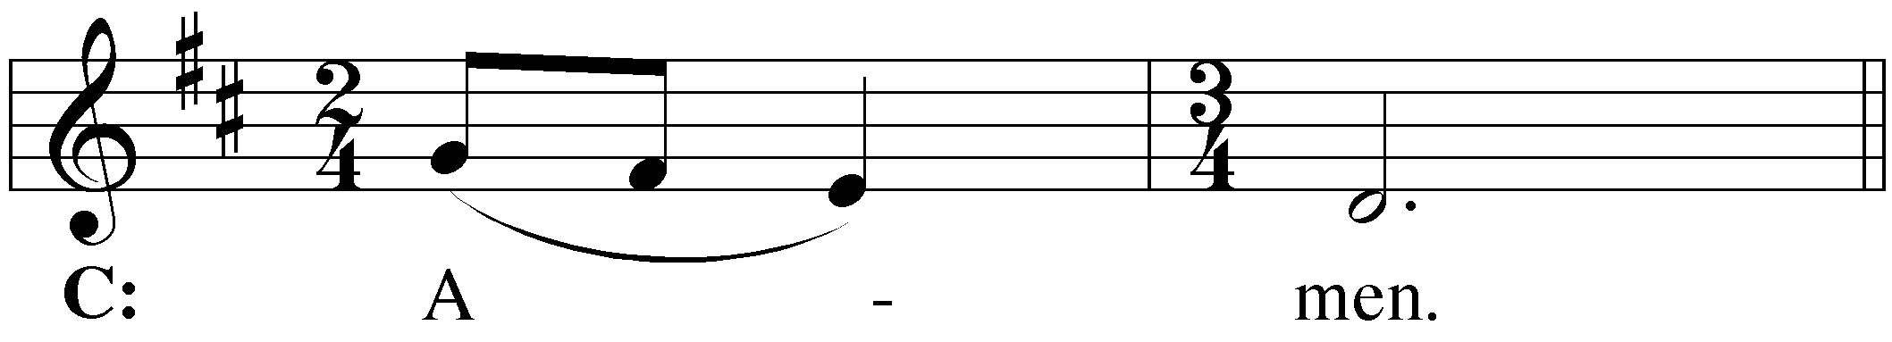

M: The grace of our Lord  Jesus Christ, and the love of God, and the fellowship of the Holy Spirit be with you.
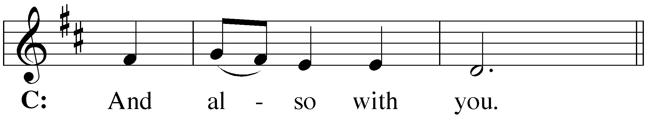

Lord, have mercy
M: The Lord Jesus comes to us and offers his grace and love. It is good for us to repent of our sins and to plead for his mercy.
The congregation may kneel.
M: Lord Jesus, you came to gather the nations into the peace of God’s kingdom. Lord, have mercy.
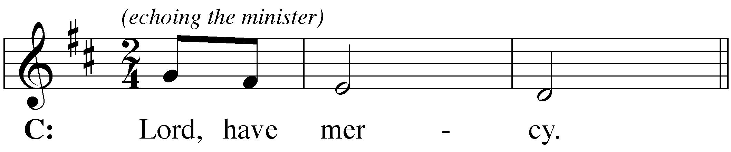

M: You come in Word and Sacrament to strengthen us in holiness. Christ, have mercy.
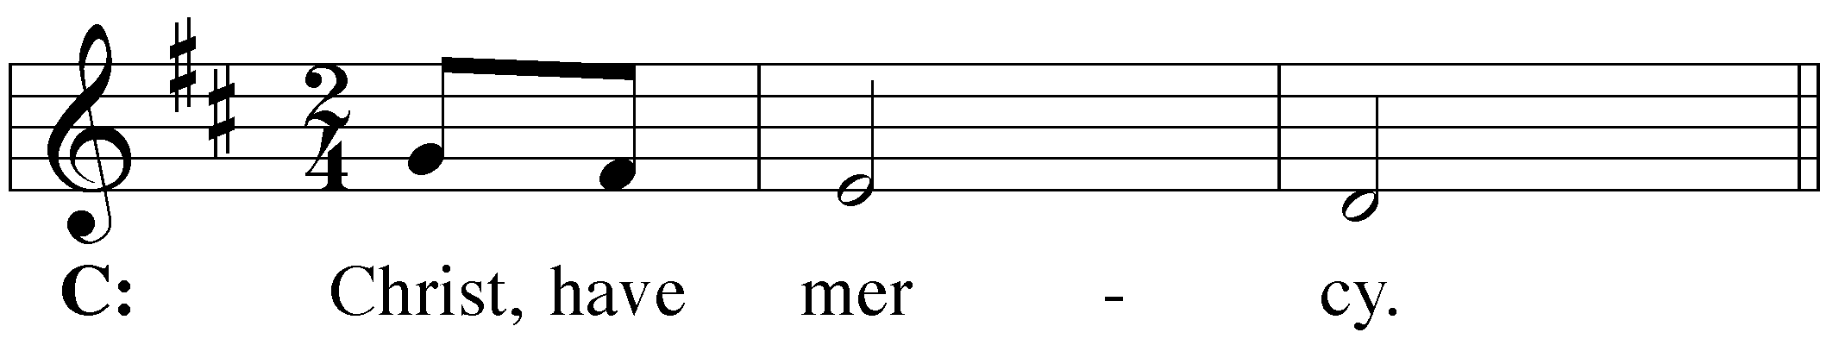

M: You will come in glory with salvation for your people. Lord, have mercy.
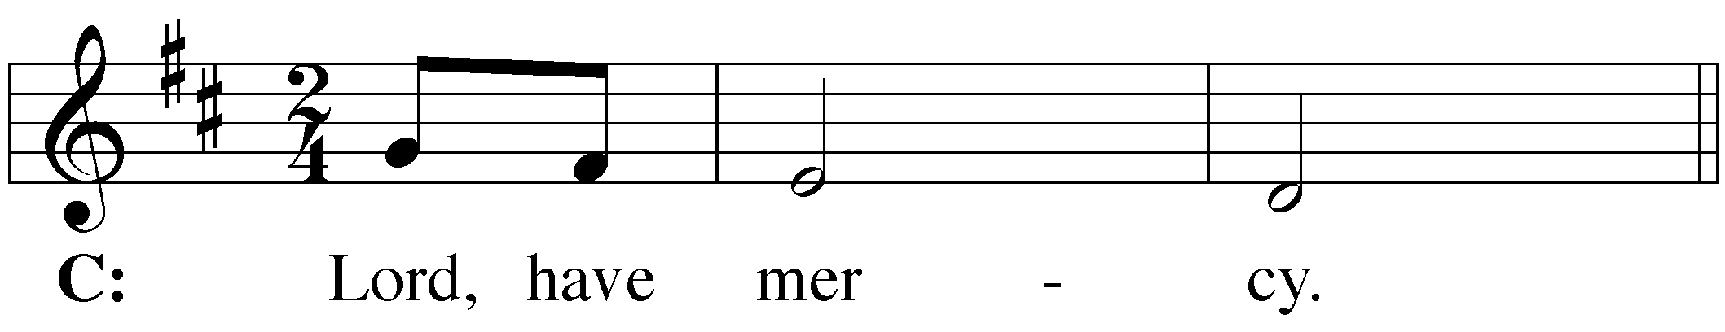

[Pastors: The Kyrie text above is not strongly penitential. It reflects, rather, a common Advent emphasis on three comings of Jesus. Since confession of sins is not essential, the wording above may be used. Or you may use other wording that reflects a stronger penitential emphasis.]

M: May almighty God, have mercy on us, forgive our sins, and bring us to everlasting life. Amen.
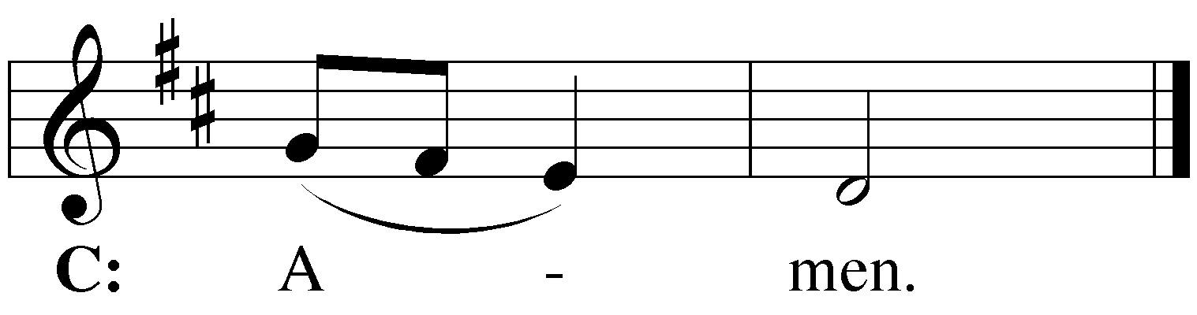

absolution
M: The almighty God has been merciful to us and has sent his Son to die for all. For his sake, he forgives us our sins and calls us from darkness to his marvelous light. Therefore, as a called servant of Christ and by his authority, I forgive you all your sins in the name of the Father and of the Son  and of the Holy Spirit.
C: Amen. (spoken)
The service continues with the Prayer of the Day.

Copyright ©2001 by GIA Publications, Inc. All Rights Reserved.

=====================================================
Notes:
- This gathering rite may be used for each Sunday in Advent. You will need copies for cantor/choir and accompanist. Order “Lead Us to Your Light” by Carol Browning, NPH #28-4495 (800-662-6022) or GIA #G-5323. Flute part: #G-5323INST.
- Listen to the audio sample. Printed in the octavo is the C instrument part heard on the recording. It is possible to do this music with only organ or piano. As on the recording, other instrumentalists may improvise parts based on the keyboard accompaniment.
- The musical score makes it possible for the Greeting and Lord Have Mercy to be sung. If the minister is comfortable singing these parts, there are other options as noted below. Be sure to adjust service format and rubrics as needed.
- The minister may speak the Greeting (with or without music continuing while he speaks).
- The Greeting may consist only of the Invocation or the Apostolic Greeting.
- The entire Greeting section may be spoken by pastor and people.
- Cantor, soloist, or choir may sing the Lord Have Mercy section. The minister may then speak the words "May Almighty God have mercy…" while the music continues softly.
- To accompany the congregation’s portions, the keyboardist leads the congregation with slightly more volume, especially when the congregation immediately follows the minister’s portion such as in “Lord, have mercy.” If playing piano or electronic keyboard, try doubling the bass line in octaves for congregation parts; on organ, use soft Manual II for the presider or choir and a stronger Manual I with Pedal for the congregation.
- Note that the absolution is not in the choir copy. It is added to strengthen the declarative character of absolution. The standard Christian Worship absolution below may be substituted for the wording above.
- When musician(s) and presiding minister have carefully planned (and rehearsed!) this gathering rite, worshipers will find it to be very easy to follow.
- The musical notation graphic in this document can be cut/pasted into other documents. To resize the graphic use the corner handle.
- Text is formatted using MS Word "styles."
- The copyright notice may appear elsewhere in the worship folder.
Christian Worship absolution
M: God, our heavenly Father, has been merciful to us and has given his only Son to be the atoning sacrifice for our sins. Therefore, as a called servant of Christ and by his authority, I forgive you all your sins in the name of the Father and of the Son  and of the Holy Spirit.
C: Amen. (spoken)

