Psalm 23

Refrain Soloist, then congregation
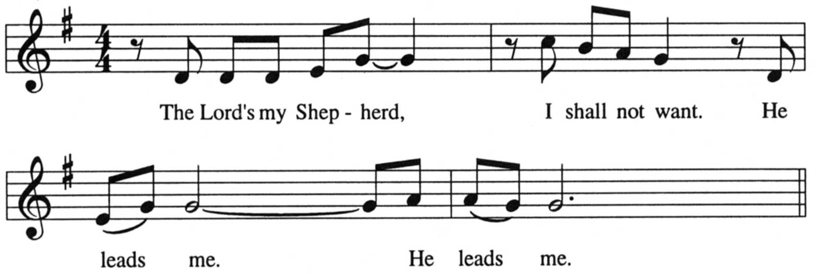

Verse Soloist He makes me lie down in green pastures.
Comments from C/W:
While this is not a newer setting, it remains one of the best responsorial settings of Psalm 23. Optional descant instrument.
"Fix typo" in file name refers to an error in the octavo's reproducible page. The typo is corrected in this version.

Order music from CPH
He leads me by still waters.

Refrain Soloist, then congregation

Verse Soloist He restores my soul.
He leads me in paths of righteousness for his name’s sake.

Refrain Soloist, then congregation

Verse Soloist Though I walk through the valley of the shadow of death,
I will fear no evil.

Refrain Soloist, then congregation

Verse Soloist You prepare a table in the presence of my enemies.
You anoint my head with oil, my cup overflows.

Refrain Soloist, then congregation

Verse Soloist Surely goodness and mercy shall follow me all the days of my life,
and I shall dwell in the house of the Lord forever and ever.

Refrain Soloist, then congregation

Setting by John Behnke. Copyright © 1997 Concordia Publishing House. Reprinted under OneLicence.net #A-706345.
The Lord’s My Shepherd
Hymn of the Day for the Fourth Sunday of Easter

