Notes from the Commission on Worship

There are a number of examples of seasonal variety and adornment of the liturgy in the following service.

* *This is the Feast of Victory* is used through the Easter season to replace the Song of Praise.
* A Proper Verse of the Day from *The Cantor Book of Gospel Acclamations* is sung by the cantor and congregation.
* The text of *These Things Did Thomas Count as Real* is printed in its entirety for the congregation because of the power and imagery of the text.
* The choral arrangement *Do Not Let Your Hearts Be Troubled* is referenced here. It is also available as #759 in *Christian Worship: Supplement.*
* The Psalm of the Day is spoken responsively.
* The information for the choral pieces are available by hyperlink below:

Do Not Let Your Hearts Be Troubled. Text and tune: © 1995 David Haas by GIA Publications. All rights reserved.

[Audio Sample](http://www.giamusic.com/mp3s/4349.mp3): This sample includes quite a bit of instrumentation. Any or all of the instruments may be omitted. The version in CWS includes optional instrumental descant parts (C and B-flat) and optional cello/bassoon part. Either could be played on an electronic keyboard.

[Preview PDF](http://www.giamusic.com/searchPDFS/G4349.pdf)

[Order it](http://www.giamusic.com/search_details.cfm?title_id=613)

These Things Did Thomas Count As Real. Text: © 1984 Thomas Troeger by Oxford University Press, Inc. All rights reserved.

[Audio Sample](http://www.cph.org/multimedia/music/shorts/singles/983901.mp3)

[Preview PDF](http://www.cph.org/pdf/983901.pdf)

[Order it](http://www.cph.org/cphstore/product.asp?category=&part_no=983901&find_category=&find_description=&find_part_desc=these+things+did+thomas+count+as+real)

*The Cantor’s Book of Gospel Acclamations from the Lectionary for Mass* © 1988 by GIA Publications, Inc. -- Alleluia. Text and tune: © 1984 Jacques Berthier by Altiers et Presses de Taizé, France, GIA Publications, Inc. All rights reserved.

[Order it](http://www.giamusic.com/products/P-4987.cfm)

Faith Lutheran Church

A Changeless Message for a Changing World

### 

### Pastor Jon Schroeder

Church Office: 770-253-4007

Home Phone: 770-253-6565

Fax: 770-253-4007

Email: [jonathaneschroeder@gmail.com](mailto:jonathaneschroeder@gmail.com)

### Those who serve:

Assistant: Vicar Caleb Bassett

Organist: Mary Beth Eckhardt

March 19, 2009 Easter 2

W

elcome! Thank you for joining us for worship this morning. In our service we gather before our almighty God to offer him our worship and praise. We also gather to strengthen ourselves through the study of God’s holy and powerful word. Please take a moment to sign our guest register in the back of the church.

* **Restrooms** are located in the hallway directly opposite the entrance to the sanctuary.
* **Cry**-**room**. If you have need of a cry-room, there is a children’s room immediately to the left as you exit the sanctuary. A speaker there allows you to hear the service.
* **Hearing assistance devices** are available. Speak to an usher.
* **Large print service folders** are available. Speak to an usher.
* **Staffed nursery is available**, down the hall to the left.

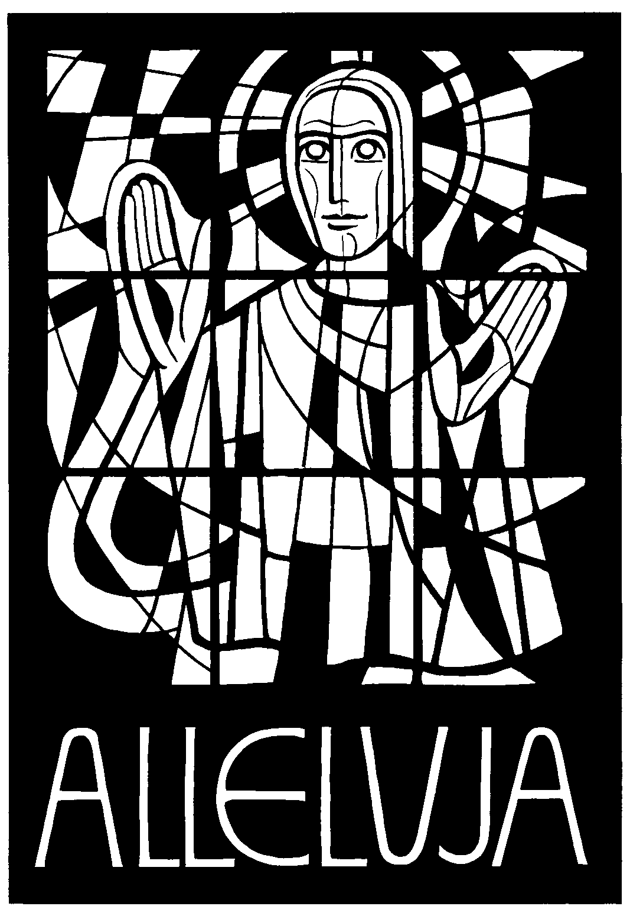

Today’s Theme:

Easter Peace

Service of the Word

Opening Hymn: #149, *Christ the Lord is Risen Today*

Invocation

L*(eader)*: In the name of the Father and of the Son and of the Holy Spirit.

C(ongregation): Amen.

L: Dear friends in Christ, today we come together to celebrate the resurrection of our Lord. Let us draw near to him in worship and in praise, in our thoughts and in our prayers.

Alleluia! Christ is Risen!

C: He is risen indeed!

Confession of Sins

L: Upon the hill the cross now stands empty. Morning light breaks upon the tomb. As we come before our God and King, let us confess our sins.

C: Lord God, I humbly come before you. I confess that I am sinful in thought, word, and deed. I daily fail to do what you command, and continually do what you forbid. Lord, I am sorry for my sins. I believe that for the sake of my Lord Jesus Christ, you will have mercy on me.

L: Upon this your sincere confession, by Christ’s command and authority, I assure you that your sins are all forgiven. The vacant cross and the empty grave are God’s signs to you that he has accepted the sacrifice of his one and only Son. Whoever believes this simple truth of Scripture has eternal life. The Lord is gracious and righteous!

C: When I was in great need, he saved me.

L: The Lord is my strength and my song;

C: He has become my salvation.

This is the Feast of Victory

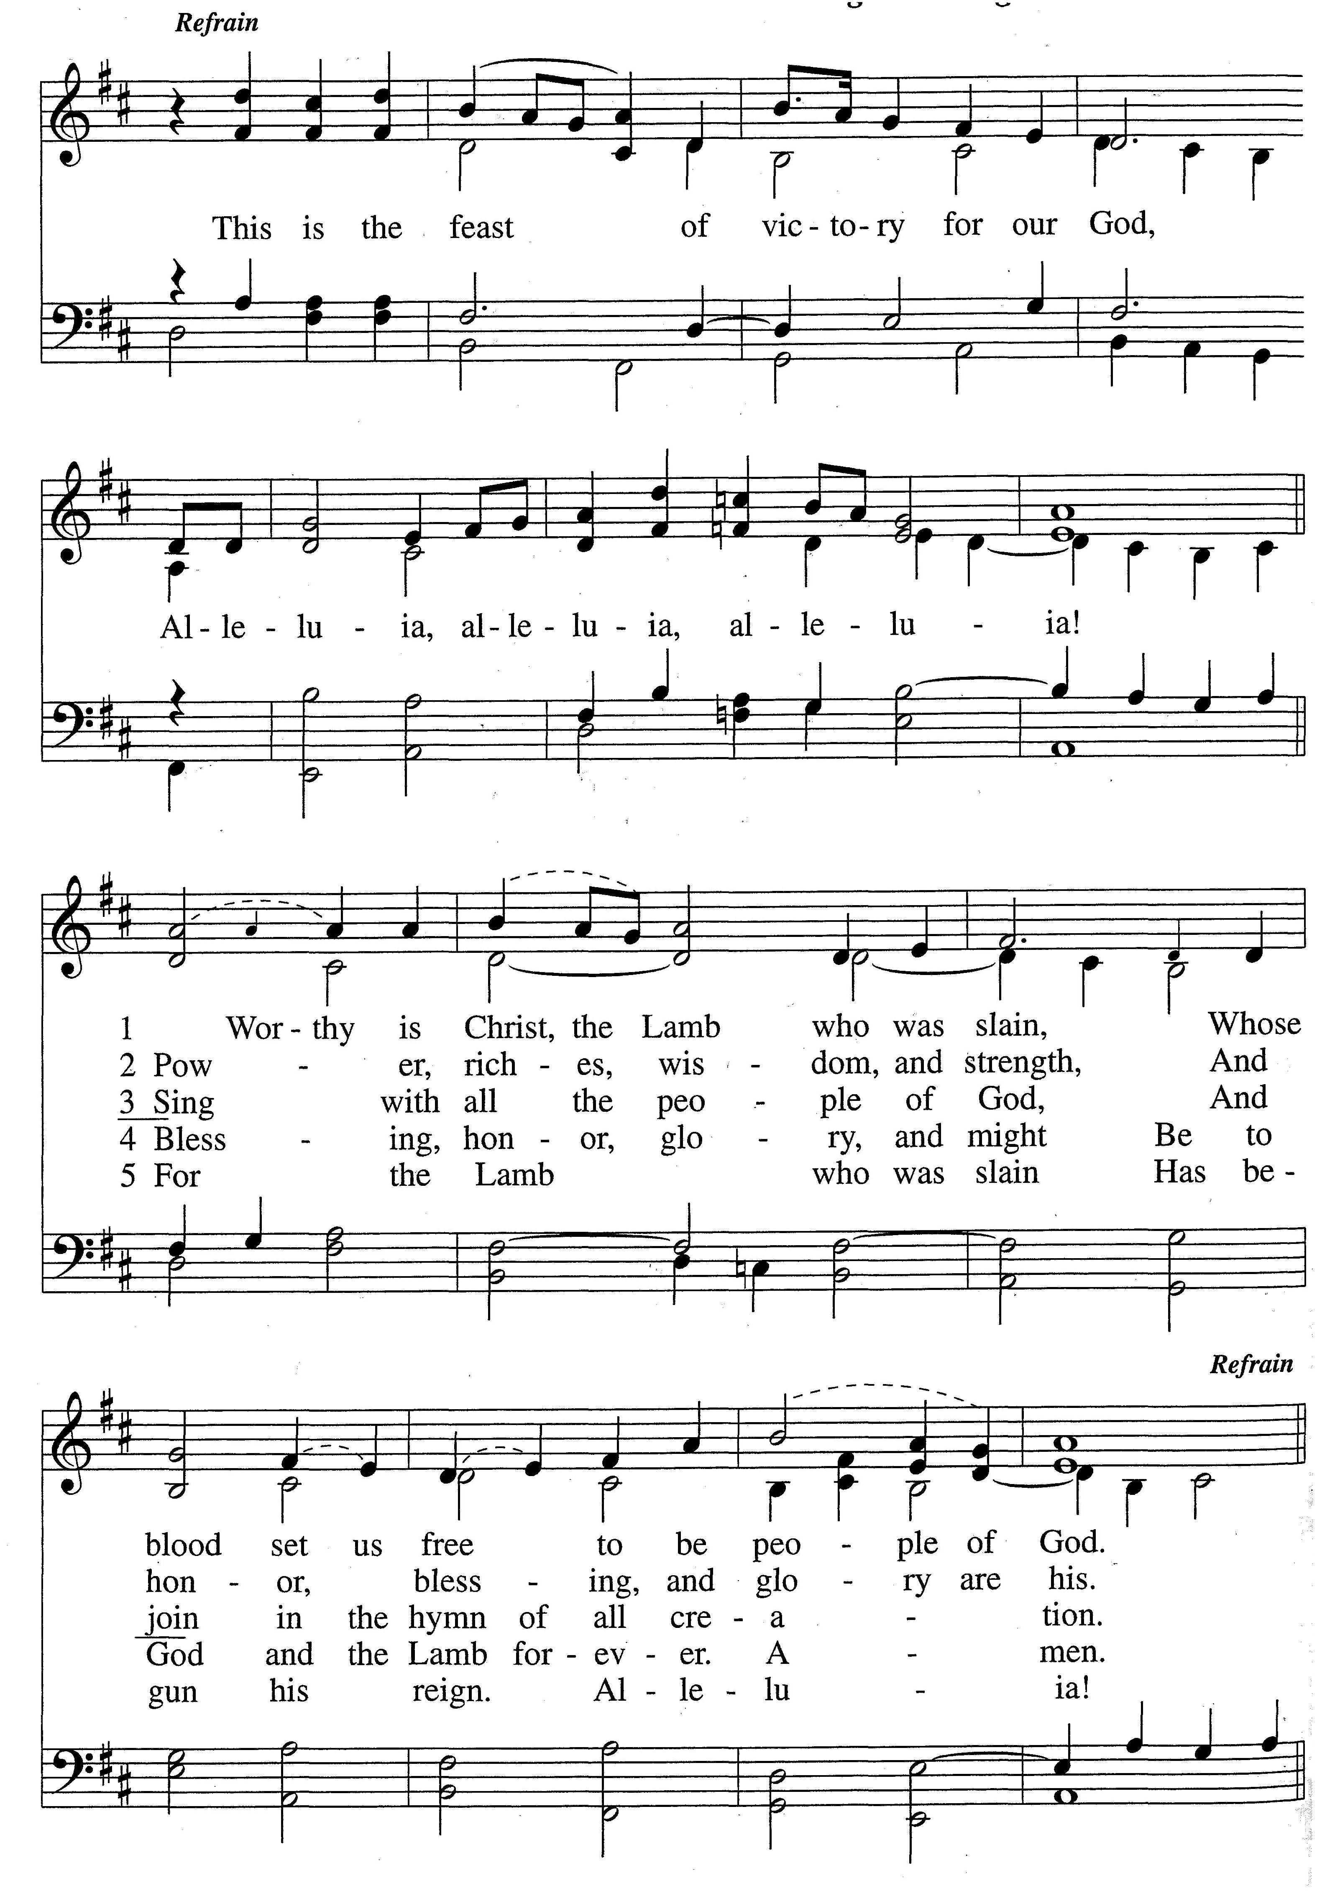

Prayer of the Day



L: Let us pray.

The leader says the Prayer of the Day.

C: Amen.

The Word of God

The Children’s Sermon

The First Lesson: Acts 3:12-20

12When Peter saw this, he said to them: "Men of Israel, why does this surprise you? Why do you stare at us as if by our own power or godliness we had made this man walk? 13The God of Abraham, Isaac and Jacob, the God of our fathers, has glorified his servant Jesus. You handed him over to be killed, and you disowned him before Pilate, though he had decided to let him go. 14You disowned the Holy and Righteous One and asked that a murderer be released to you. 15You killed the author of life, but God raised him from the dead. We are witnesses of this. 16By faith in the name of Jesus, this man whom you see and know was made strong. It is Jesus' name and the faith that comes through him that has given this complete healing to him, as you can all see.

17"Now, brothers, I know that you acted in ignorance, as did your leaders. 18But this is how God fulfilled what he had foretold through all the prophets, saying that his Christ would suffer. 19Repent, then, and turn to God, so that your sins may be wiped out, that times of refreshing may come from the Lord, 20and that he may send the Christ, who has been appointed for you—even Jesus.

The Psalm of the Day: Psalm 16

Read responsively with the leader.

L: Keep me safe, O God.

C: for in you I take refuge.

L: I said to the Lord, “You are my Lord;

C: apart from you I have no good thing.”

L: I have set the Lord always before me.

C: Because he is at my right hand, I will not be shaken.

L: My heart is glad and my tongue rejoices;

C: my body also will rest secure,

L: because you will not abandon me to the grave,

C: nor will you let your Holy One see decay.

L: You have made known to me the path of life;

C: you will fill me with joy in your presence.

The Second Lesson: 1 John 5:1-6

1Everyone who believes that Jesus is the Christ is born of God, and everyone who loves the father loves his child as well. 2This is how we know that we love the children of God: by loving God and carrying out his commands. 3This is love for God: to obey his commands. And his commands are not burdensome, 4for everyone born of God overcomes the world. This is the victory that has overcome the world, even our faith. 5Who is it that overcomes the world? Only he who believes that Jesus is the Son of God.

6This is the one who came by water and blood—Jesus Christ. He did not come by water only, but by water and blood. And it is the Spirit who testifies, because the Spirit is the truth.

The Verse of the Day

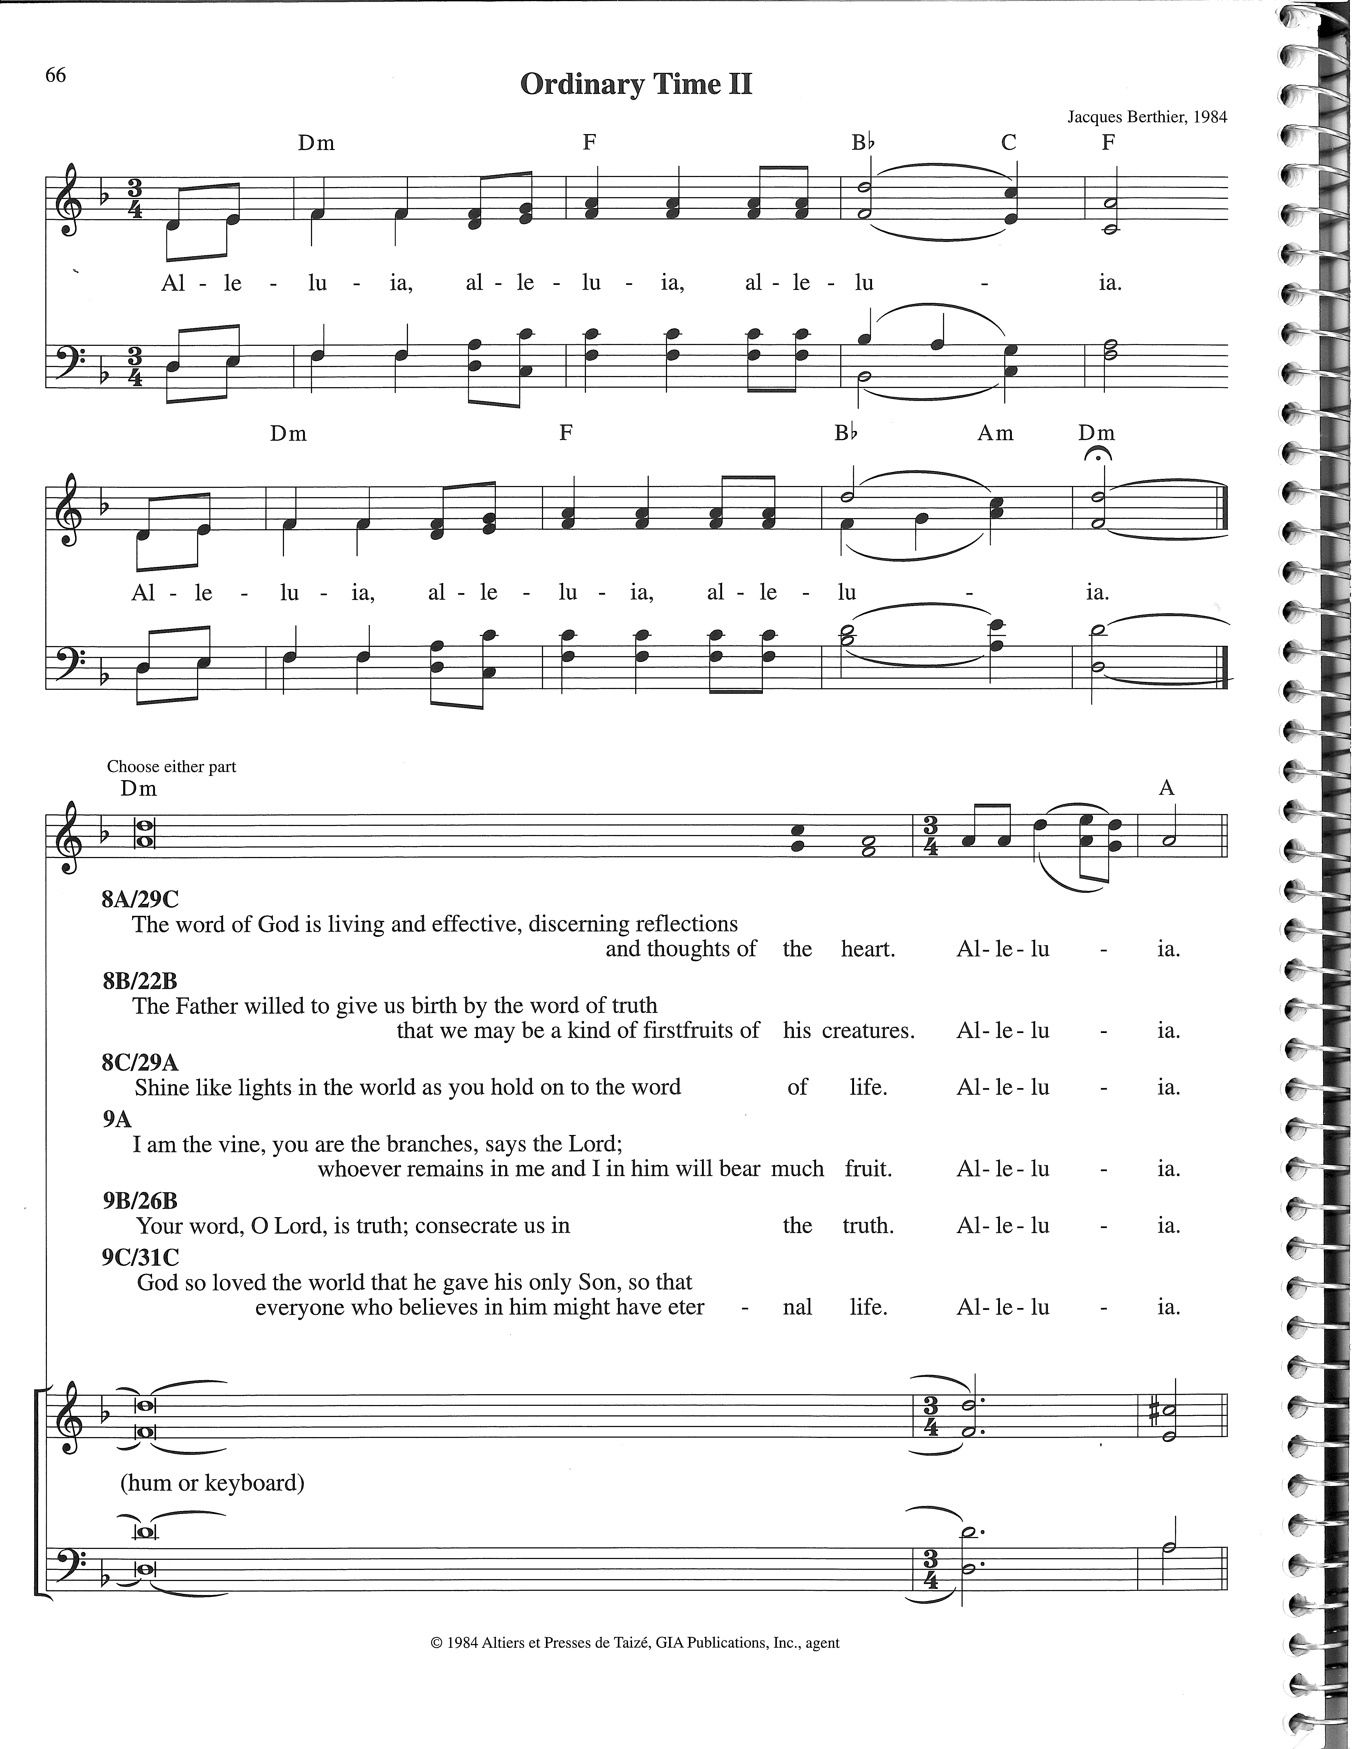

Cantor: Refrain

All: Refrain

Cantor: Blessed are those who have not seen and yet have believed. Alleluia. (John 20:29)

All: Refrain

The Gospel Lesson: John 20:19-31

19On the evening of that first day of the week, when the disciples were together, with the doors locked for fear of the Jews, Jesus came and stood among them and said, "Peace be with you!" 20After he said this, he showed them his hands and side. The disciples were overjoyed when they saw the Lord.

21Again Jesus said, "Peace be with you! As the Father has sent me, I am sending you." 22And with that he breathed on them and said, "Receive the Holy Spirit. 23If you forgive anyone his sins, they are forgiven; if you do not forgive them, they are not forgiven."

24Now Thomas (called Didymus), one of the Twelve, was not with the disciples when Jesus came. 25So the other disciples told him, "We have seen the Lord!"   
      But he said to them, "Unless I see the nail marks in his hands and put my finger where the nails were, and put my hand into his side, I will not believe it."

26A week later his disciples were in the house again, and Thomas was with them. Though the doors were locked, Jesus came and stood among them and said, "Peace be with you!" 27Then he said to Thomas, "Put your finger here; see my hands. Reach out your hand and put it into my side. Stop doubting and believe."

28Thomas said to him, "My Lord and my God!"

29Then Jesus told him, "Because you have seen me, you have believed; blessed are those who have not seen and yet have believed."

30Jesus did many other miraculous signs in the presence of his disciples, which are not recorded in this book. 31But these are written that you may believe that Jesus is the Christ, the Son of God, and that by believing you may have life in his name.



The Hymn of the Day: #165, *O Sons and Daughters of the King*

*Verse 1: All*

*Verses 2-3: Women*

*Verses 4-5: Men*

*Verses 6-9: All*

The Sermon:

In the Face of Doubt

1. Christ Gives Peace
2. Christ Gives Proof

The Apostles’ Creed

I believe in God, the Father almighty, maker of heaven and earth.

I believe in Jesus Christ, his only Son, our Lord, who was conceived by the Holy Spirit, born of the Virgin Mary, suffered under Pontius Pilate, was crucified, died, and was buried. He descended into hell. The third day he rose again from the dead. He ascended into heaven and is seated at the right hand of God the Father almighty. From there he will come to judge the living and the dead.

I believe in the Holy Spirit, the holy Christian Church, the communion of saints, the forgiveness of sins, the resurrection of the body, and the life everlasting. Amen.

Thanksgiving

The Offering:

The members of Faith Lutheran Congregation have joined together to do the Lord's work in this community and around the world. Visitors need not feel obligated to participate in this offering which supports our ministry.

The Choir:

*These Things Did Thomas Count As Real* Thomas Troeger

These things did Thomas count as real: the warmth of blood, the chill of steel, the grain of wood, the heft of stone, the last frail twitch of flesh and bone.

The vision of this skeptic mind was keen enough to make him blind to any unexpected act too large for his small world of fact.

His reasoned certainties denied that one could live when one had died, until, until his fingers read like Braille the markings of the spear and nail.

May we, O God, by grace believe and thus the risen Christ receive, imprinted palms reached out and beckoned Thomas from his doubt.

The Prayer of the Church:

The Lord’s Prayer:

C: Our Father, who art in heaven, hallowed be thy name,

thy kingdom come, thy will be done on earth as it is in heaven.

Give us this day our daily bread; and forgive us our trespasses, as we forgive those who trespass against us; and lead us not into temptation, but deliver us from evil. For thine is the kingdom and the power and the glory

forever and ever. Amen.

The Lord’s Blessing

L: Brothers and sisters, go in peace. Live in harmony with one another. Serve the Lord with gladness.

The Lord bless you and keep you.

The Lord make his face shine on you and be gracious to you.

The Lord look on you with favor and give you peace.

C: Amen.

The Closing Hymn: *Do Not Let Your Hearts Be Troubled*

Congregation sings the refrain and the choir sings the verses.

**Refrain**

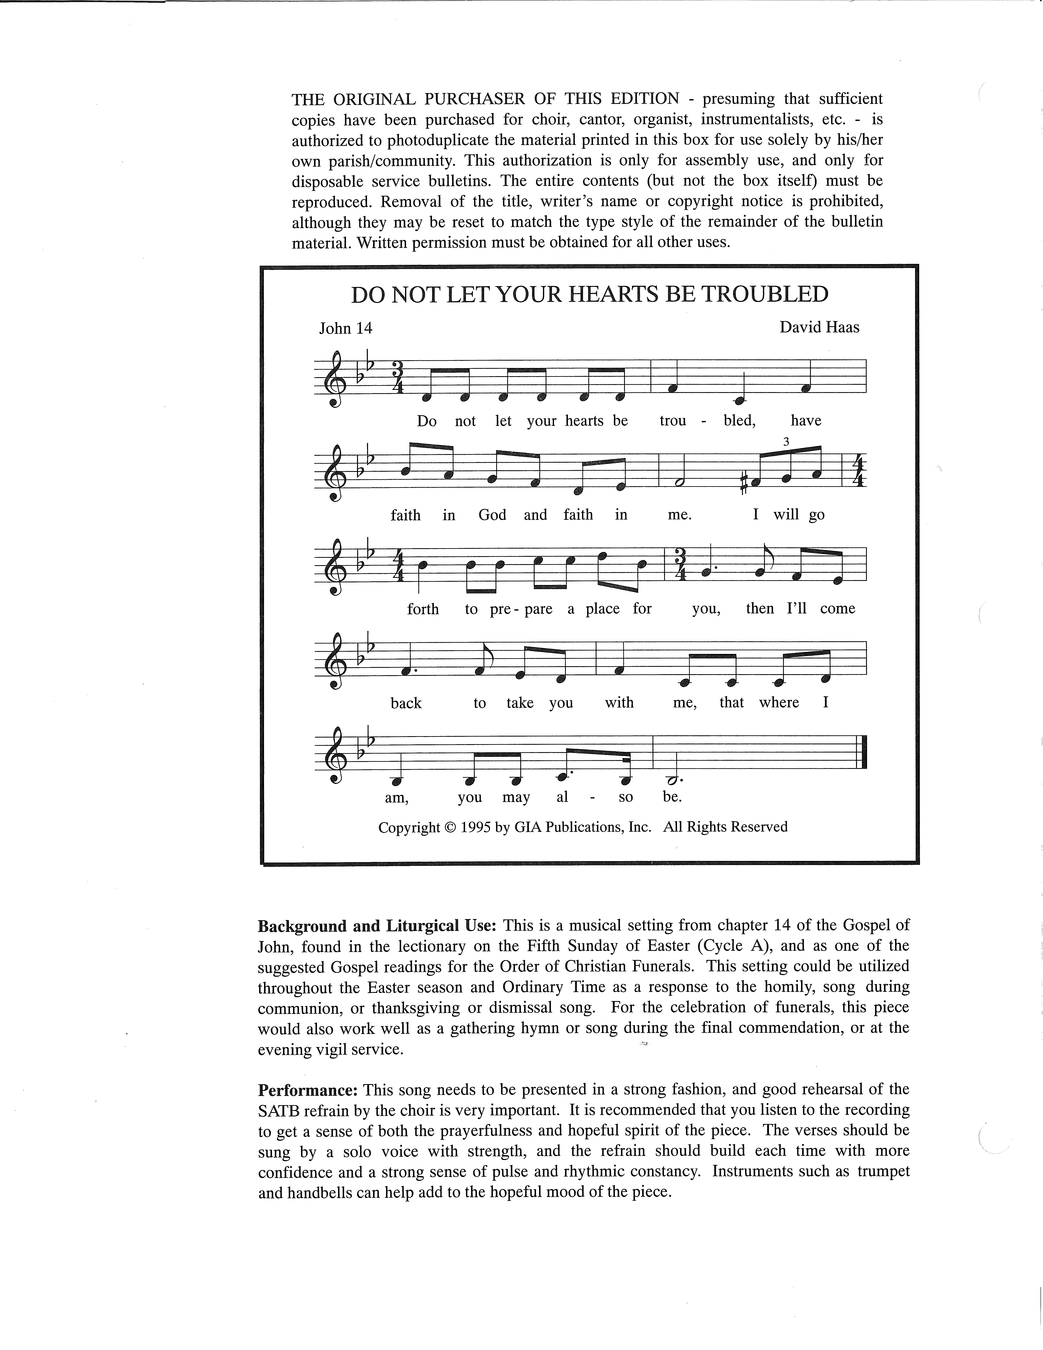

In God’s house there are many places for you alone to dwell in safety.

You know the way to where I’ll lead you, if you are lost, I will show the way.

Refrain

I am the way, the truth and the life, only through me can you know what I know.

If you knew me, you would see the vision, if you see me, you see your God.

Refrain

The words I speak are not only of myself, it is your God who lives within me.

If you believe that your God and I are one, I will provide when you call my name.

Refrain

Refrain

*The following items are reprinted under OneLicense.net #*A-709467

This is the Feast of Victory. Text: © *Lutheran Book of Worship* 1978 by Augsburg Fortress. All rights reserved.

*The Cantor’s Book of Gospel Acclamations from the Lectionary for Mass* © 1988 by GIA Publications, Inc. -- Alleluia. Text and tune:

© 1984 Jacques Berthier by Altiers et Presses de Taizé, France, GIA Publications, Inc. All rights reserved.

Do Not Let Your Hearts Be Troubled. Text and tune: © 1995 David Haas by GIA Publications. All rights reserved.

These Things Did Thomas Count As Real. Text: © 1984 Thomas Troeger by Oxford University Press, Inc. All rights reserved.