God is our refuge and strength, an ever-present help in trouble.
Psalm 46:1

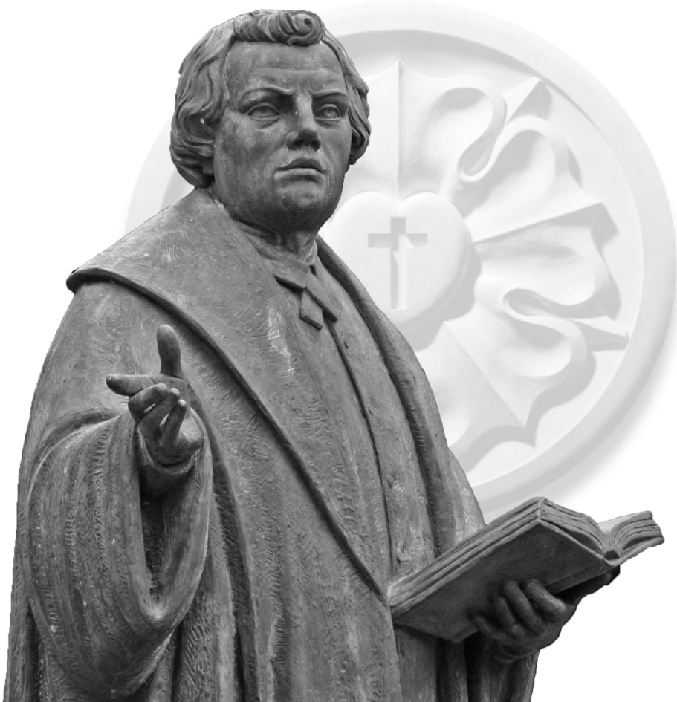

A Commemoration of
The Lutheran Reformation of the Church

Wisconsin Lutheran Seminary
Mequon, Wisconsin

October 26, 2014 – 3:30 p.m.

Reformation 2017

Plans are in the making around the Christian world to celebrate the 500th anniversary of the Reformation in 2017. Sites long neglected in the Luther lands, located in what was East Germany for many years, are being renovated and returned to their 16th century splendor. We can expect to see a resurgence of interest in the social and political influence of the Reformation and especially on the impact Luther’s writings had on the freedom of Christian men and women to read and interpret the Scriptures without the dictates of the existing church. We Lutherans will find special joy in this celebration as we thank the Lord of the Church for using Martin Luther and the Lutheran reformers to restore the biblical principles of grace, faith, and Scripture.

A committee made up of members of WELS is presently working on plans to celebrate this notable anniversary. The news arrived recently that plans include the production of a documentary on the life and legacy of Martin Luther.

A committee chaired by Pastor Martin Wildauer of St. Matthew, Port Washington, is also making plans for this celebration in the Southeastern Wisconsin District. An important component of this plan is to lead members of our district to join in special worship events over the next three years, culminating in a district wide worship opportunity in 2017.

We encourage today’s worshipers to return to their congregations and share their enthusiasm for these special times of coming together to hear and proclaim in word and song the blessings of God through the Reformation.

Verbum Dei Manet in Aeternum
The Word of God remains forever

Welcome to Wisconsin Lutheran Seminary

Wisconsin Lutheran Seminary is pleased to host this Reformation Service. Guests are encouraged to walk around the campus following the service. The chapel, classroom, and library are open for guests to visit. Those desiring a tour of the buildings may meet tour guides at the main entrance under the tower arch.
Order of Service

Please observe silence during the pre-service music.

Pre-service music Prelude and Fugue in E♭ Major (BWV 552)
Johann Sebastian Bach

HYMN The Church’s One Foundation
Christian Worship 538
Setting by Paul Manz

Introduction

All
The Church’s one foundation is Jesus Christ, her Lord;
She is his new creation by water and the Word.
From heav’n he came and sought her To be his holy bride;
With his own blood he bought her, And for her life he died.

Interlude

Women
Elect from ev’ry nation, yet one o’er all the earth;
Her charter of salvation: one Lord, one faith, one birth.
One holy name she blesses, partakes one holy food,
And to one hope she presses, with ev’ry grace endued.

Interlude

Men
The Church shall never perish. her dear Lord, to defend,
To guide, sustain, and cherish, is with her to the end.
Though there be those that hate her and strive to see her fail,
Against both foe and traitor She ever shall prevail.

Interlude

Choir
Though with a scornful wonder the world sees her oppressed,
By schisms rent asunder, by heresies distressed,
Yet saints their watch are keeping; their cry goes up, “How long?”
And soon the night of weeping shall be the morn of song.

Interlude; stand

All
Mid toil and tribulation and tumult of her war
She waits the consummation of peace forevermore
Till with the vision glorious her longing eyes are blest
And the great Church victorious shall be the Church at rest.

INVOCATION

M: In the name of the Father and of the Son and of the Holy Spirit.

C: Amen.

DIALOGUE FOR REFORMATION

In the words spoken by the minister, Dr. Luther remembered his “tower experience” in which he came to understand the central teaching of the Scriptures.

M: In the meantime in the same year (1519) I had begun again to lecture on the Psalter, believing that with my classroom experience in lecturing on the Psalms and the Letters of Paul to the Romans, Galatians, and Hebrews, I was now better prepared.

C: The Lord has made his salvation known and revealed his righteousness to the nations. He has remembered his love and his faithfulness to the house of Israel; all the ends of the earth have seen the salvation of our God.

M: All the while I was absorbed with the passionate desire to get better acquainted with the author of Romans. Not that I did not succeed, as I had resolved, in penetrating more deeply into the subject in my investigation, but I stumbled over the words concerning “the righteousness of God revealed in the gospel.” For the concept of God’s righteousness was repulsive to me, as I was accustomed to interpret it according to scholastic philosophy, namely as the “formal or active” righteousness, in which God proves himself righteous in that he punishes the sinner as an unrighteous person.

C: In you, O Lord, I have taken refuge; let me never be put to shame. Rescue me and deliver me in your righteousness; turn your ear to me and save me.

M: After days and nights of wrestling with the problem, God finally took pity on me, so that I was able to comprehend the inner connection between the two expressions, “the righteousness of God is revealed in the gospel” and “the just shall live by faith.”

C: But now a righteousness from God, apart from law, has been made known, to which the Law and the Prophets testify. This righteousness from God comes through faith in Jesus Christ.

M: Then I began to comprehend the righteousness of God through which the righteous are saved by God’s grace, namely, through faith; that the righteousness of God which is revealed through the gospel was to be understood in a passive sense in which God through mercy justifies man by faith, as it is written, “The just shall live by faith.” Now I felt exactly as though I had been born again, and I believed that I had entered Paradise through widely opened doors.

C: God made him who had no sin to be sin for us, so that in him we might become the righteousness of God.

M: I then went through the Holy Scriptures as far as I could recall them from memory, and I found in other parts the same sense: the “work of God” is that which he works in us, the “strength of God” is that through which he makes us strong, the “wisdom of God” that through which he makes us wise, and so the “power of God,” the “blessing of God,” and the “honor of God” are likewise to be interpreted.

C: It is because of him that you are in Christ Jesus, who has become for us wisdom from God—that is, our righteousness, holiness and redemption. Therefore, as it is written: “Let him who boasts boast in the Lord.”

M: As violently as I had formerly hated the expression “the righteousness of God,” so I was now as violently compelled to embrace the new conception of grace and, thus, for me, the expression of the apostle really opened the gates of paradise.

C: Now there is in store for me the crown of righteousness, which the Lord, the righteous Judge, will award to me on that day—and not only to me, but also to all who have longed for his appearing.

SONG OF PRAISE If God Is for Us
Setting by James Chepponis

The choirs sing the refrain. All repeat the refrain and sing it again as indicated.

The choirs sing the verses of the song.

God is our refuge and our strength, an ever present aid,
and therefore, though the earth be moved, we will not be afraid;
Though hills into the seas be cast, though foaming waters roar,
the Lord of hosts is by our side, a refuge strong and sure.

Refrain

A river flows whose streams make glad the city of our God,
the holy dwelling of the Lord, the place of God’s abode.
Since God is in the midst of it, our safety is secure;
the Lord of hosts is by our side, a refuge strong and sure.

Refrain

Behold, the wondrous deeds of God who causes wars to cease;
The weapons of the strong destroyed, God brings abiding peace.
“Be still and know that I am God, exalted evermore;”
the Lord of hosts is by our side, a refuge strong and sure.

Refrain

PRAYER OF THE DAY

M: Almighty God, through the preaching of your servants, the blessed Reformers, you caused the light of the gospel to shine forth. Grant that we may faithfully defend it against all enemies and joyfully proclaim it to the salvation of people everywhere to the glory of your holy name; through your Son Jesus Christ our Lord, who lives and reigns with you and the Holy Spirit, one God, now and forever.

C: Amen.

Be seated.

FIRST LESSON Isaiah 55:1-11
God’s Word offers the forgiveness of sins, life, and salvation.

PSALM OF THE DAY Psalm 98
Setting by John A. Behnke

The choir sings the refrain. All repeat the refrain.

Refrain

The choir sings the psalm.

His right hand and his holy arm have won him the victory.
The Lord has made his victory known.

Refrain (the choir first; then the congregation)

He has remembered his steadfast love, he has remembered his faithfulness.
All the ends of the earth have seen his victory

Refrain (the choir first; then the congregation)

All the earth make a joyful noise! Break forth in joyous song and sing to the Lord!

Refrain (the choir first; then the congregation)

Let the sea roar and all that fills it, let the floods clap their hands,
Let the hills sing for joy for he comes to judge the earth,
For he comes to judge the earth.

Refrain (the choir first; then the congregation)
SECOND LESSON 1 Timothy 1:12-17
God extends his grace to sinners.

RESPONSE Rejoice in God, All Christendom
Heinrich Schütz

Rejoice in God, all Christendom  Your hearts and voices raising,  With glad new songs before him come,  His wondrous mercy praising.  Sing unto him with psaltery,  Let harps and strings accompany  Your hymns of praise and honor | The Word of God is always true,  And we may trust it ever.  What he has promised, he will do;  The Lord will fail us never.  He judgment loves and righteousness;  The earth which he did make and bless  Is full of his great goodness.

Our soul doth wait for thee, O Lord.
Our help and our protection.
Our heart rejoiceth in thy Word,
We trust in thy direction.
Thy mercy, Lord, upon us be
According as we hope in thee;
Thou art our mighty refuge.

Stand for the Gospel.

GOSPEL Matthew 11:1-15
Jesus foretells the courageous march of the gospel through history.

Following the Gospel:

M: The Gospel of the Lord.

C: Thanks be to God!

Be seated.

ANTHEM What Then
Words – Romans 8:31-39
Hymn stanza by Edward Mote
Music by John Ferguson

What then are we to say about these things?
If God is for us, who is against us?
Who will separate us from the love of Christ?
Will hardship, distress, persecution, famine, nakedness, peril, or sword? What then?
No! In all these things we are more than conquerors through him who loved us.

My hope is built on nothing less than Jesus’ blood and righteousness.
No merit of my own I claim, but wholly lean on Jesus’ name.
On Christ, the solid rock, I stand; all other ground is sinking sand.
What then are we to say about these things? Alleluia!
HYMN A Mighty Fortress Is Our God
Christian Worship 200
Setting by Charles Schramm

A mighty fortress is our God, a trusty shield and weapon;
He helps us free from ev’ry need that has us now o’ertaken.
The old evil foe now means deadly woe;
Deep guile and great might are his dread arms in fight;
On earth is not his equal.

With might of ours can naught be done; soon were our loss effected.
But for us fights the valiant one whom God himself elected.
You ask, “Who is this?” Jesus Christ it is,
The almighty Lord. And there’s no other God;
He holds the field forever.

Meditate silently on Luther’s words as they are interpreted in an organ setting by Jonathan Reuss

Though devils all the world should fill, all eager to devour us,
We tremble not, we fear no ill; they shall not overpow’r us.
This world’s prince may still scowl fierce as he will,
He can harm us none. He’s judged; the deed is done!
One little word can fell him.

Interlude; stand

The Word they still shall let remain, nor any thanks have for it;
He’s by our side upon the plain with his good gifts and Spirit.
And do what they will—hate, steal, hurt, or kill—
Though all may be gone, our victory is won;
The kingdom’s ours forever!

SERMON 1 Timothy 1:12-17

True Lutherans Get Grace

The absolute need for grace
The surprising nature of grace
The grateful response to grace

WE PRAISE YOU,GOD
Te Deum Laudamus

Luther valued the ancient Te Deum Laudamus and suggested it might be considered among the ecumenical creeds of the Christian Church. Speak the words of the canticle as a confession of faith.

We praise you, O God, we acclaim you as Lord;
All creation worships you, Father everlasting.
To you all angels, all the powers of heaven,
Cherubim and seraphim, sing in endless praise:
Holy, holy, holy Lord, God of heavenly hosts,
Heaven and earth are full of your glory.
The glorious company of apostles praise you.
The noble fellowship of prophets praise you.
The white-robed army of martyrs praise you.
Throughout the world the holy Church acclaims you:
Father of majesty unbounded, your glorious, true and only Son,
And the Holy Spirit, advocate and guide.
You, Christ, are the King of glory,
The eternal Son of the Father.

When you became man to set us free,
You humbled yourself to be born of a virgin.
You overcame the sting of death
And opened the kingdom of heaven to all believers.
You sit at the right hand of God in the glory of the Father.
We believe that you will come to be our judge.

Come then, Lord, and help your people,
Bought with the price of your own blood,
And bring us with your saints to glory everlasting.

Be seated

OFFERING Prelude on ERHALT UNS HERR
David Johnson

After covering expenses for this service, the offering is designated to support district plans to observe the 500th anniversary of the Reformation in 2017.

A LITANY OF REMEMBRANCE

Stand.

M: With grateful hearts, O Lord
C: We remember before you this day…

M: That great cloud of witnesses whose living trust in you, recorded in your Word, becomes an example for us to imitate and follow.
C: Inspire us as we remember them, O Lord.

M: With grateful hearts, O Lord
C: We remember before you this day…

M: The reformers and confessors who faced the terror of church and empire but stood firm in your truth because they were moved by grace, empowered by faith, and guided by Scripture.
C: Inspire us as we remember them, O Lord.

M: With grateful hearts, O Lord
C: We remember before you this day…

M: Your faithful followers of every age, among them our own mothers and fathers, pastors and teachers, called, gathered, enlightened and sanctified by the Holy Spirit to be your Church and by whose faithful witness the gospel of your grace has reached at last to us.
C: Inspire us as we remember them, O Lord.

M: With grateful hearts, O Lord
C: We remember before you this day…

M: The early and present leaders of our synod, the teachers who trained our grandfathers and those who now teach us, the missionaries who once went to lands uncharted and unmapped, and those who now walk among teeming millions in over-crowded cities.
C: Inspire us as we remember them, O Lord.

M: With grateful hearts, O Lord
C: We remember before you this day…

M: Our own loved ones whose memories still burn within our hearts, whom you have called in your good time from their labors in life to that life which knows no end.
C: Inspire us as we remember them, O Lord,

M: To carry on their work in this our day, trusting your Son, holding to your Word, confessing your truth, loving the lost, reaching out with your love, until you call us, too, by your great grace in Jesus Christ, to join them where memories are swallowed up by everlasting joy.
C: Amen.

LORD’S PRAYER

Our Father in heaven, hallowed be your name, your kingdom come, your will be done on earth as in heaven. Give us today our daily bread. Forgive us our sins as we forgive those who sin against us. Lead us not into temptation, but deliver us from evil. For the kingdom, the power, and the glory are yours now and forever. Amen.

Be seated

HYMN Not Unto Us
Christian Worship 392

Not unto us, not unto us be glory, Lord;
Not unto us but to your name be praise;
Not unto us but to your name all honor be giv’n
For matchless mercy, forgiveness, and grace.

Amazing grace—that chose us e’er the worlds were made;
Amazing grace—that sent your Son to save;
Amazing grace—that robed us in your righteousness
And taught our lips to sing glory and praise.

O faithful love—that shepherded through faithless years;
Forgiving love—that led us to your truth;
Unyielding love—that would not let us turn from you
But sent us forth to speak pardon and peace.

Not unto us but to your name be glory, Lord,
For grace so rich, so wide, so high, so free.
Abide with us till trav’ling days are over and done,
And pilgrim feet lead us home, Lord, to you.

Stand

PRAYER

M: Almighty God, grant to your Church the Holy Spirit and the wisdom that comes from above. Let nothing hinder your Word from being freely proclaimed to the joy and edifying of Christ’s holy people, so that we may serve you in steadfast faith and confess your name as long as we live, through Jesus Christ, our Lord, who lives and reigns with you and the Holy Spirit, one God, now and forever.

C: Amen.

BLESSING

M: The Lord bless you and keep you.
The Lord make his face shine on you and be gracious to you.
The Lord look on you with favor and give you peace.

C: Amen. (spoken)

Remain standing for the hymn

HYMN Lord, Keep Us Steadfast in Your Word
Christian Worship 203

Lord, keep us steadfast in your Word;  Curb those who by deceit or sword  Would seek to overthrow your Son  And to destroy what he has done. | Lord Jesus Christ, your pow’r make known,  For you are Lord of lords alone;  Defend your Christendom that we  May sing your praise eternally.

O Comforter of priceless worth,
Send peace and unity on earth.
Support us in our final strife,
And lead us out of death to life.

Be seated

POSTLUDE Toccata in E minor
Eugène Gigout

Serving at Worship

Presiding Minister Pastor John Roekle
First Evangelical Lutheran Church
Racine, Wisconsin

Preacher Prof. Joel Otto
Wisconsin Lutheran Seminary
Mequon, Wisconsin

Organist Pastor Aaron Christie
Trinity Lutheran Church
Waukesha, Wisconsin

Choirs The Lutheran Chorale of Milwaukee
Mary Prange, director
Milwaukee, Wisconsin
Lynn Kozlowski, accompanist
Wauwatosa, Wisconsin

The Seminary Chorus
Prof. James Tiefel, director
Mequon, Wisconsin

Instrumentalists Peter Plagenz, Nathan Loersch
Lucas Proeber, and Joshua Jensen, trumpet
Aaron Jensen, Nathanael Brenner
and Benjamin Rusch, trombone
Michael Schwab, percussion

ACKNOWLEDGMENTS

If God Is for Us – Refrain copyright © 2004 by GIA Publications, Inc. All rights reserved.
Note unto Us - Text: © 1975 Kurt J. Eggert. All rights reserved. Used by permission.

