This paragraph is only for planners. If the service begins with a Palm Sunday procession or reading, see that option in Service Builder under Occasional/Seasonal Services. Congregations without Service Builder may access a similar rite in CW: Occasional Services (2004). The service below includes Holy Communion. Changes can be made if the sacrament is not offered. The sermon may be shorter than usual or even omitted, especially if longer hymn responses are used along with the Palm Sunday beginning and/or Holy Communion.

If using thematic summaries from the Year A Planner (from The Foundation), make adjustments as needed. Sample explanation: Today's service begins with the account of Jesus’ triumphal entry into Jerusalem and then moves to the monumental story of his suffering and death. The juxtaposition of these two readings emphasizes that Palm Sunday led directly to Good Friday. Both days were part of our Savior’s saving work. While their tone could not have been more different, their purpose was the same: the salvation of all people.

The Word
Prayer of the Day
Let us pray.

Almighty and everlasting God, you sent your Son, our Savior Jesus Christ, to take upon himself our flesh and suffer death upon the cross. Mercifully grant that we may follow the example of his great humility and patience and be made partakers of his resurrection; through your Son, Jesus Christ our Lord, who lives and reigns with you and the Holy Spirit, one God, now and forever.
Amen.

Be seated

The History of Our Lord's Suffering and Death according to St. Matthew

Part One
The Plot Against Jesus
26:1 When Jesus had finished saying all these things, he said to his disciples, 2 “As you know, the Passover is two days away—and the Son of Man will be handed over to be crucified.”
3 Then the chief priests and the elders of the people assembled in the palace of the high priest, whose name was Caiaphas, 4 and they schemed to arrest Jesus secretly and kill him. 5 “But not during the festival,” they said, “or there may be a riot among the people.”

Jesus Anointed at Bethany
6 While Jesus was in Bethany in the home of Simon the Leper, 7 a woman came to him with an alabaster jar of very expensive perfume, which she poured on his head as he was reclining at the table.
8 When the disciples saw this, they were indignant. “Why this waste?” they asked. 9 “This perfume could have been sold at a high price and the money given to the poor.”
10 Aware of this, Jesus said to them, “Why are you bothering this woman? She has done a beautiful thing to me. 11 The poor you will always have with you, but you will not always have me. 12 When she poured this perfume on my body, she did it to prepare me for burial. 13 Truly I tell you, wherever this gospel is preached throughout the world, what she has done will also be told, in memory of her.”

Hymn CW 395 st. 1
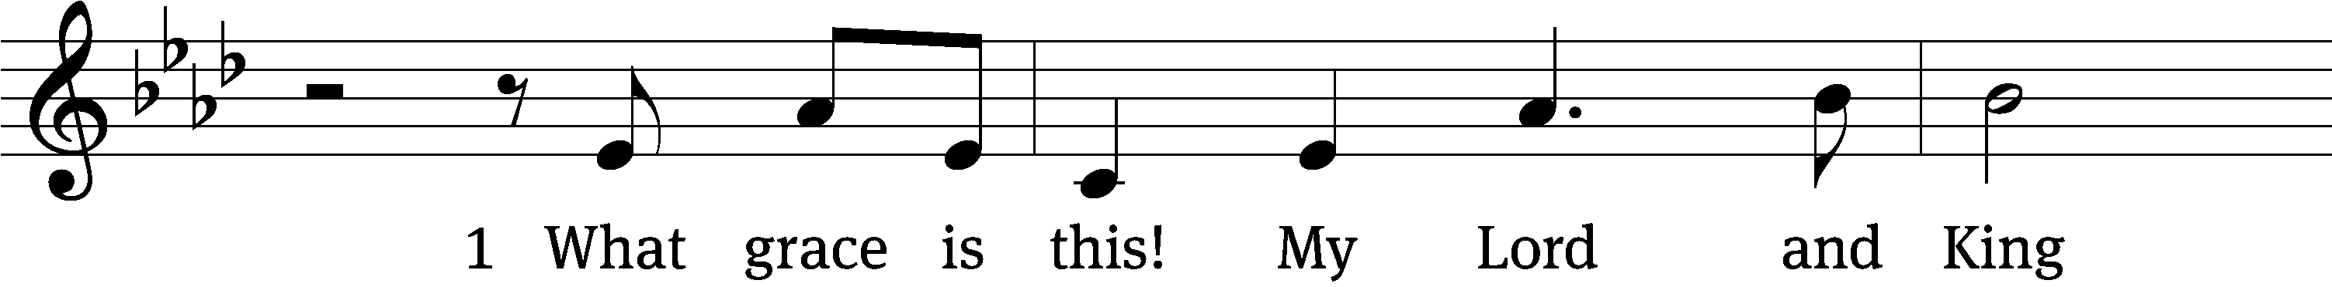

For copyright reasons, the complete hymn is not shown.
Text: Laurie F. Gauger, b. 1965
Tune: G. A. Hennig, b. 1966
Text: © 2005 Laurie F. Gauger, admin. Faith Alive Christian Resources. Used by permission: OneLicense no. ######
Tune: © 2005 G. A. Hennig, admin. Faith Alive Christian Resources. Used by permission: OneLicense no. ######

Part Two
Judas Agrees to Betray Jesus
14 Then one of the Twelve—the one called Judas Iscariot—went to the chief priests 15 and asked, “What are you willing to give me if I deliver him over to you?” So they counted out for him thirty pieces of silver. 16 From then on Judas watched for an opportunity to hand him over.

The Last Supper
17 On the first day of the Festival of Unleavened Bread, the disciples came to Jesus and asked, “Where do you want us to make preparations for you to eat the Passover?”
18 He replied, “Go into the city to a certain man and tell him, ‘The Teacher says: My appointed time is near. I am going to celebrate the Passover with my disciples at your house.’” 19 So the disciples did as Jesus had directed them and prepared the Passover.
20 When evening came, Jesus was reclining at the table with the Twelve. 21 And while they were eating, he said, “Truly I tell you, one of you will betray me.”
22 They were very sad and began to say to him one after the other, “Surely you don’t mean me, Lord?”
23 Jesus replied, “The one who has dipped his hand into the bowl with me will betray me. 24 The Son of Man will go just as it is written about him. But woe to that man who betrays the Son of Man! It would be better for him if he had not been born.”
25 Then Judas, the one who would betray him, said, “Surely you don’t mean me, Rabbi?”
Jesus answered, “You have said so.”
26 While they were eating, Jesus took bread, and when he had given thanks, he broke it and gave it to his disciples, saying, “Take and eat; this is my body.”
27 Then he took a cup, and when he had given thanks, he gave it to them, saying, “Drink from it, all of you. 28 This is my blood of the covenant, which is poured out for many for the forgiveness of sins. 29 I tell you, I will not drink from this fruit of the vine from now on until that day when I drink it new with you in my Father’s kingdom.”
30 When they had sung a hymn, they went out to the Mount of Olives.

Hymn CW 417 sts. 1–4
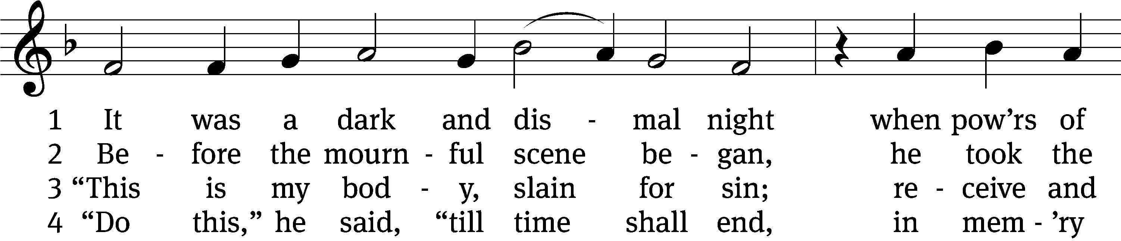
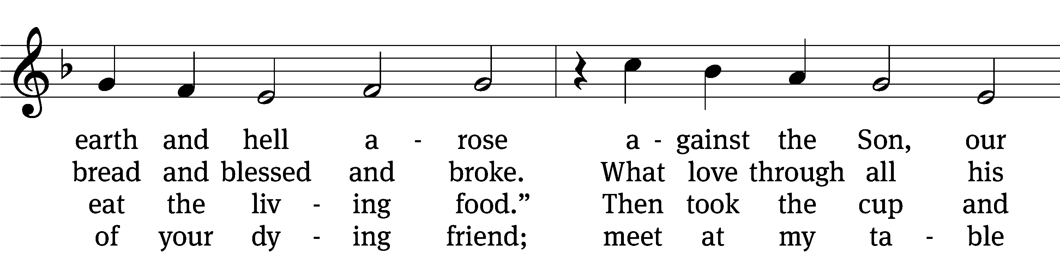
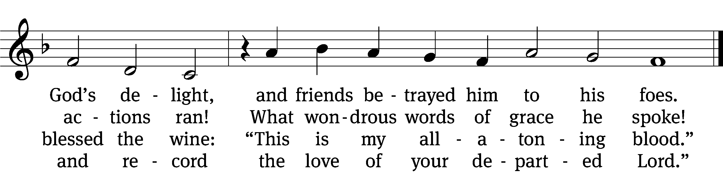
Text: Isaac Watts, 1674–1748, abr., alt.
Tune: Louis Bourgeois, c. 1510–c. 1561
Text and tune: Public domain

Part Three
Jesus Predicts Peter’s Denial
31 Then Jesus told them, “This very night you will all fall away on account of me, for it is written:
“‘I will strike the shepherd,
and the sheep of the flock will be scattered.’
32 But after I have risen, I will go ahead of you into Galilee.”
33 Peter replied, “Even if all fall away on account of you, I never will.”
34 “Truly I tell you,” Jesus answered, “this very night, before the rooster crows, you will disown me three times.”
35 But Peter declared, “Even if I have to die with you, I will never disown you.” And all the other disciples said the same.

Hymn CW 430 sts. 1–2
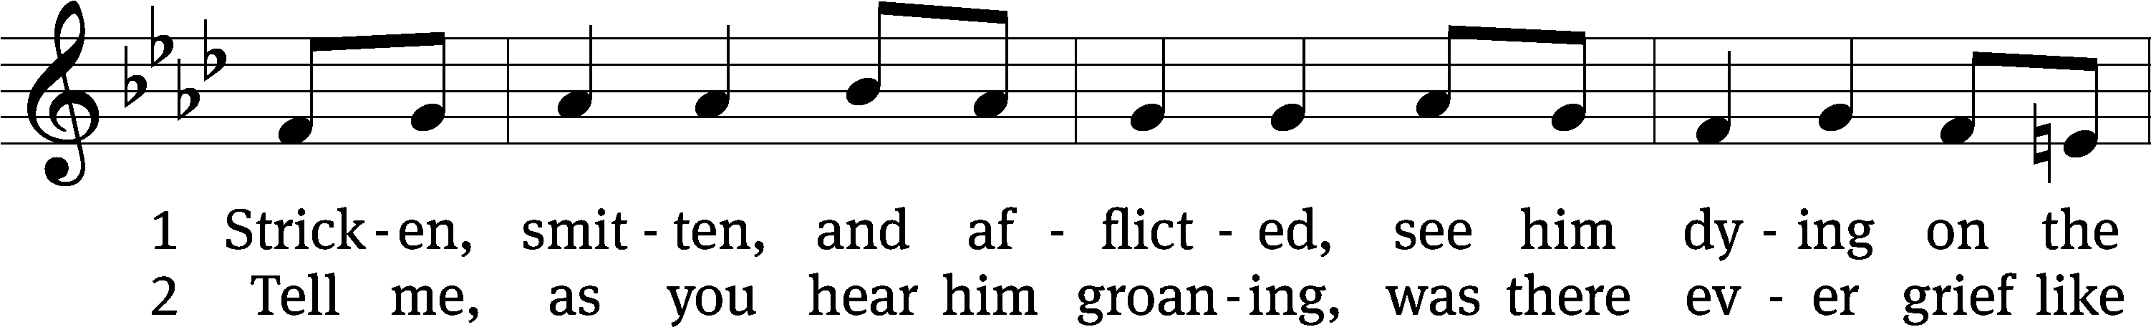
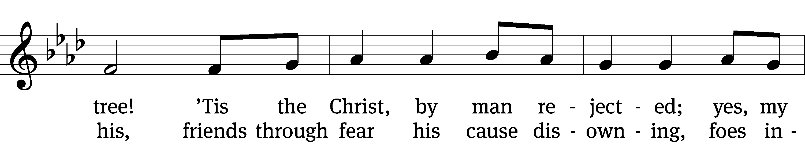
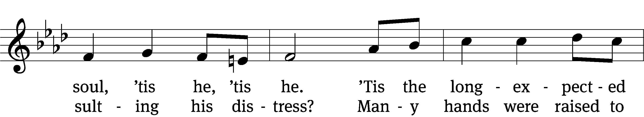
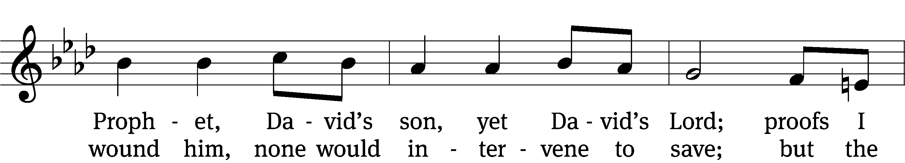
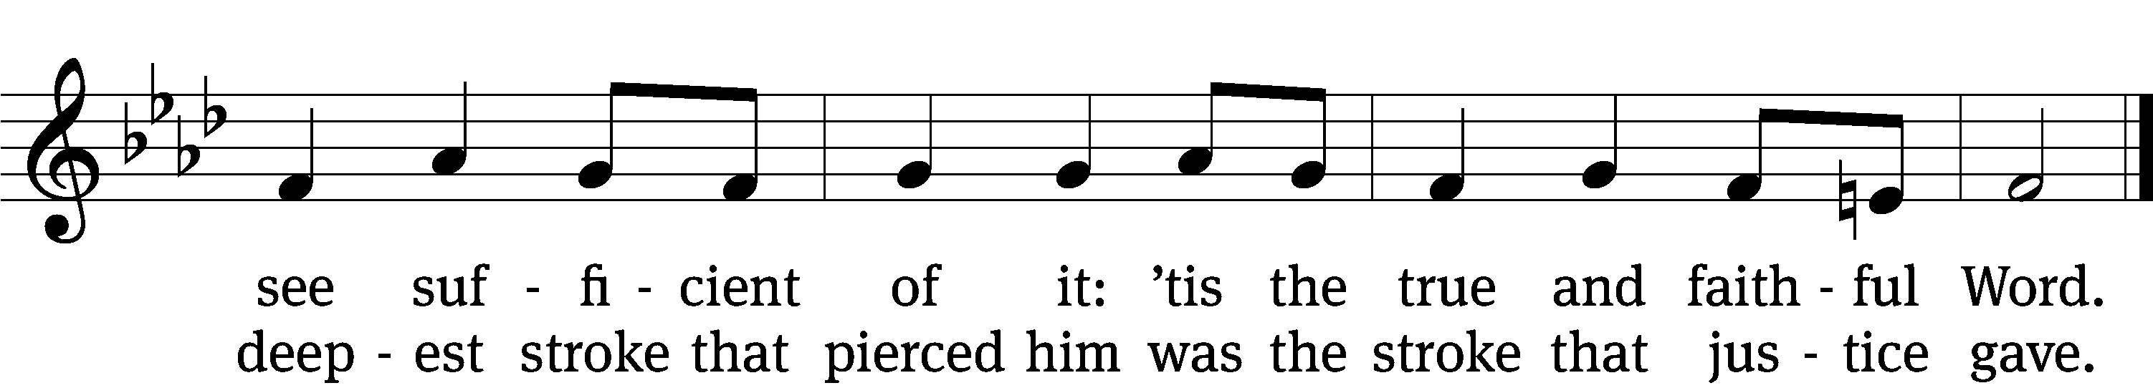
Text: Thomas Kelly, 1769–1855, alt.
Tune: Geistliche Volkslieder, Paderborn, 1850
Text and tune: Public domain

Part Four
Gethsemane
36 Then Jesus went with his disciples to a place called Gethsemane, and he said to them, “Sit here while I go over there and pray.” 37 He took Peter and the two sons of Zebedee along with him, and he began to be sorrowful and troubled. 38 Then he said to them, “My soul is overwhelmed with sorrow to the point of death. Stay here and keep watch with me.”
39 Going a little farther, he fell with his face to the ground and prayed, “My Father, if it is possible, may this cup be taken from me. Yet not as I will, but as you will.”
40 Then he returned to his disciples and found them sleeping. “Couldn’t you men keep watch with me for one hour?” he asked Peter. 41 “Watch and pray so that you will not fall into temptation. The spirit is willing, but the flesh is weak.”
42 He went away a second time and prayed, “My Father, if it is not possible for this cup to be taken away unless I drink it, may your will be done.”
43 When he came back, he again found them sleeping, because their eyes were heavy. 44 So he left them and went away once more and prayed the third time, saying the same thing.
45 Then he returned to the disciples and said to them, “Are you still sleeping and resting? Look, the hour has come, and the Son of Man is delivered into the hands of sinners. 46 Rise! Let us go! Here comes my betrayer!”

Hymn CW 425 sts. 1–2
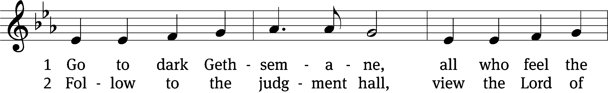
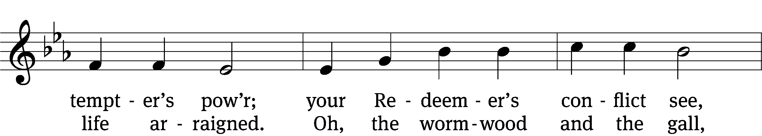
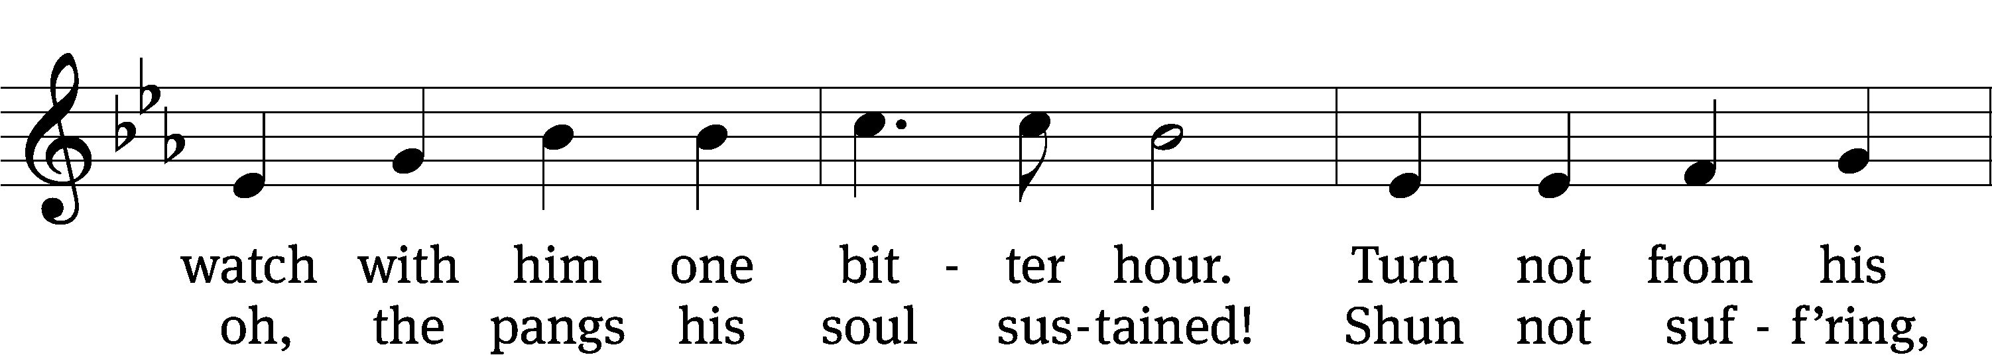
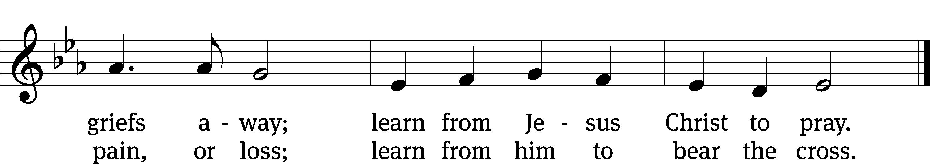
Text: James Montgomery, 1771–1854, alt.
Tune: Richard Redhead, 1820–1901
Text and tune: Public domain

Part Five
Jesus Arrested
47 While he was still speaking, Judas, one of the Twelve, arrived. With him was a large crowd armed with swords and clubs, sent from the chief priests and the elders of the people. 48 Now the betrayer had arranged a signal with them: “The one I kiss is the man; arrest him.” 49 Going at once to Jesus, Judas said, “Greetings, Rabbi!” and kissed him.
50 Jesus replied, “Do what you came for, friend.”
Then the men stepped forward, seized Jesus and arrested him. 51 With that, one of Jesus’ companions reached for his sword, drew it out and struck the servant of the high priest, cutting off his ear.
52 “Put your sword back in its place,” Jesus said to him, “for all who draw the sword will die by the sword. 53 Do you think I cannot call on my Father, and he will at once put at my disposal more than twelve legions of angels? 54 But how then would the Scriptures be fulfilled that say it must happen in this way?”
55 In that hour Jesus said to the crowd, “Am I leading a rebellion, that you have come out with swords and clubs to capture me? Every day I sat in the temple courts teaching, and you did not arrest me. 56 But this has all taken place that the writings of the prophets might be fulfilled.” Then all the disciples deserted him and fled.

Hymn CW 422 sts. 1–2
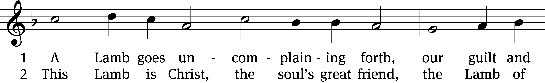

For copyright reasons, the complete hymn is not shown.

Text: tr. The Lutheran Hymnal, 1941, alt.; Paul Gerhardt, 1607–1676, abr.
Tune: Wolfgang Dachstein, c. 1487–1553
Text: © 1941 Concordia Publishing House. Used by permission: OneLicense no. ######
Tune: Public domain

Part Six
Jesus Before the Sanhedrin
57 Those who had arrested Jesus took him to Caiaphas the high priest, where the teachers of the law and the elders had assembled. 58 But Peter followed him at a distance, right up to the courtyard of the high priest. He entered and sat down with the guards to see the outcome.
59 The chief priests and the whole Sanhedrin were looking for false evidence against Jesus so that they could put him to death. 60 But they did not find any, though many false witnesses came forward.
Finally two came forward 61 and declared, “This fellow said, ‘I am able to destroy the temple of God and rebuild it in three days.’”
62 Then the high priest stood up and said to Jesus, “Are you not going to answer? What is this testimony that these men are bringing against you?” 63 But Jesus remained silent.
The high priest said to him, “I charge you under oath by the living God: Tell us if you are the Messiah, the Son of God.”
64 “You have said so,” Jesus replied. “But I say to all of you: From now on you will see the Son of Man sitting at the right hand of the Mighty One and coming on the clouds of heaven.”
65 Then the high priest tore his clothes and said, “He has spoken blasphemy! Why do we need any more witnesses? Look, now you have heard the blasphemy. 66 What do you think?”
“He is worthy of death,” they answered.
67 Then they spit in his face and struck him with their fists. Others slapped him 68 and said, “Prophesy to us, Messiah. Who hit you?”

Hymn CW 408 sts. 1–2
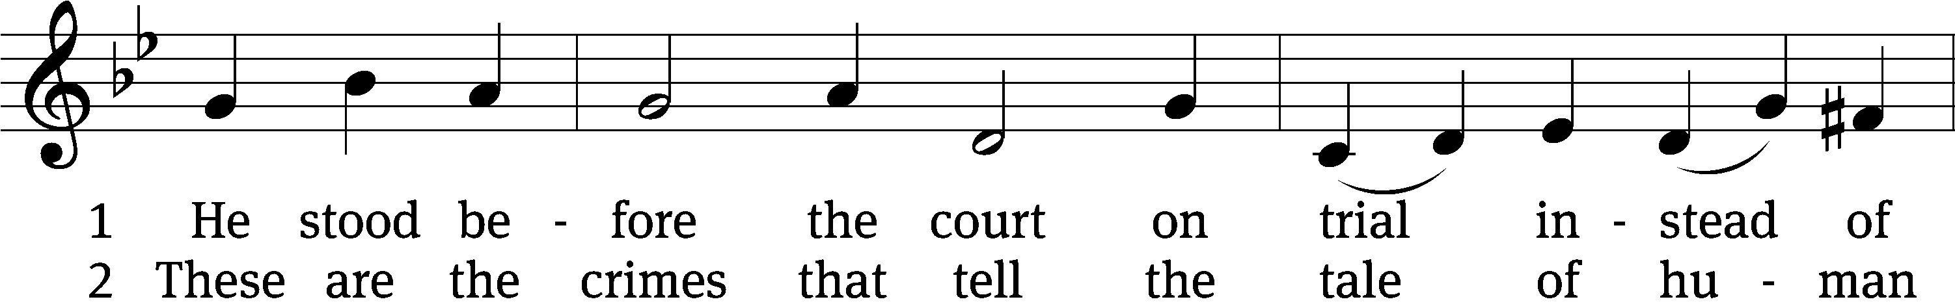

For copyright reasons, the complete hymn is not shown.

Text: Christopher M. Idle, b. 1938, alt.
Tune: Leland B. Sateren, 1913–2007
Text: © 1982 The Jubilate Group, admin. Hope Publishing Co. Used by permission: OneLicense no. ######
Tune: © 1958 Service Book and Hymnal, admin. Augsburg Fortress. Used by permission: OneLicense no. ######

Part Seven
Peter Disowns Jesus
69 Now Peter was sitting out in the courtyard, and a servant girl came to him. “You also were with Jesus of Galilee,” she said.
70 But he denied it before them all. “I don’t know what you’re talking about,” he said.
71 Then he went out to the gateway, where another servant girl saw him and said to the people there, “This fellow was with Jesus of Nazareth.”
72 He denied it again, with an oath: “I don’t know the man!”
73 After a little while, those standing there went up to Peter and said, “Surely you are one of them; your accent gives you away.”
74 Then he began to call down curses, and he swore to them, “I don’t know the man!”
Immediately a rooster crowed. 75 Then Peter remembered the word Jesus had spoken: “Before the rooster crows, you will disown me three times.” And he went outside and wept bitterly.

Hymn CW 406 st. 1
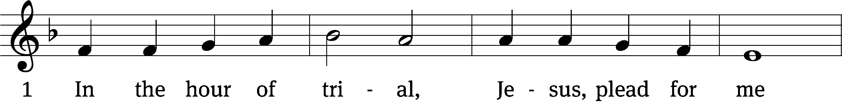
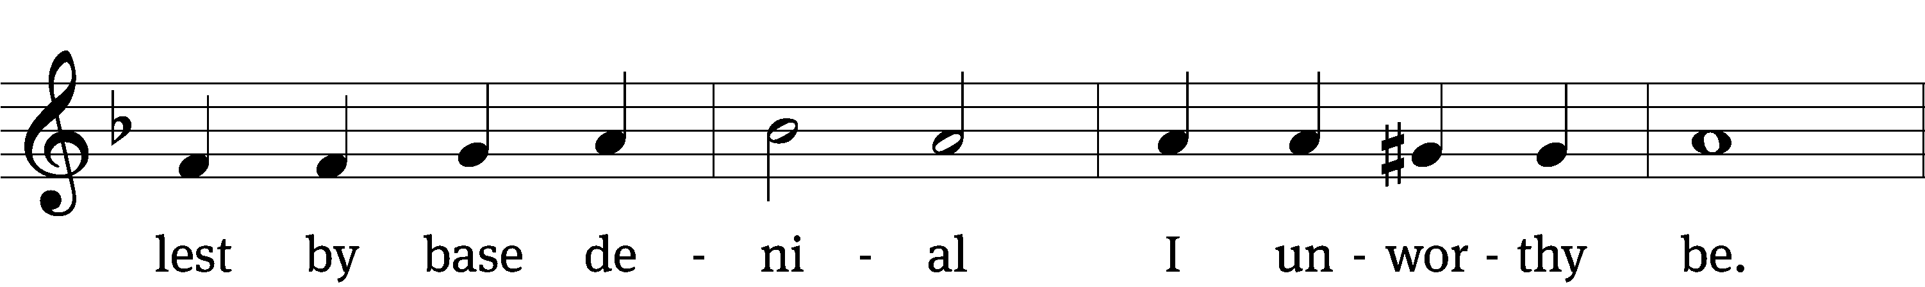
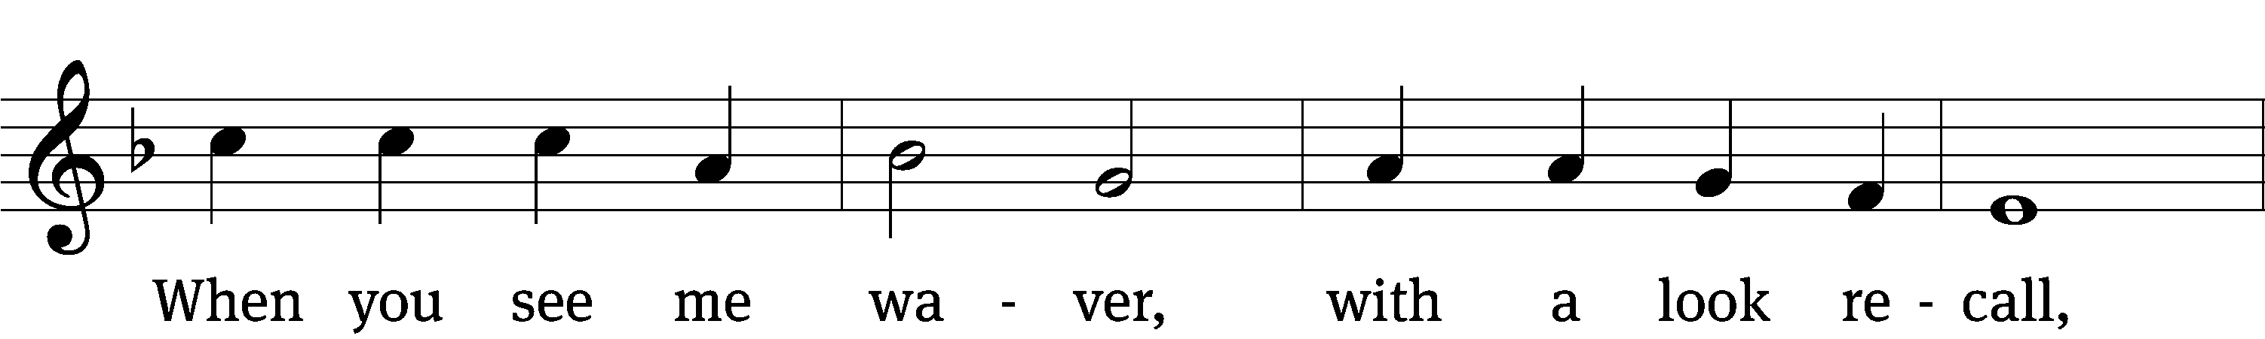
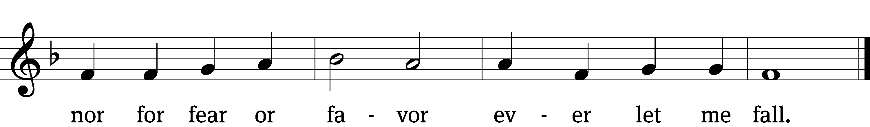
Text: James Montgomery, 1771–1854, alt.
Tune: John B. Dykes, 1823–1876
Text and tune: Public domain

Part Eight
Judas Hangs Himself
27:1 Early in the morning, all the chief priests and the elders of the people made their plans how to have Jesus executed. 2 So they bound him, led him away and handed him over to Pilate the governor.
3 When Judas, who had betrayed him, saw that Jesus was condemned, he was seized with remorse and returned the thirty pieces of silver to the chief priests and the elders. 4 “I have sinned,” he said, “for I have betrayed innocent blood.”
“What is that to us?” they replied. “That’s your responsibility.”
5 So Judas threw the money into the temple and left. Then he went away and hanged himself.
6 The chief priests picked up the coins and said, “It is against the law to put this into the treasury, since it is blood money.” 7 So they decided to use the money to buy the potter’s field as a burial place for foreigners. 8 That is why it has been called the Field of Blood to this day. 9 Then what was spoken by Jeremiah the prophet was fulfilled: “They took the thirty pieces of silver, the price set on him by the people of Israel, 10 and they used them to buy the potter’s field, as the Lord commanded me.”

Hymn CW 409 st. 1
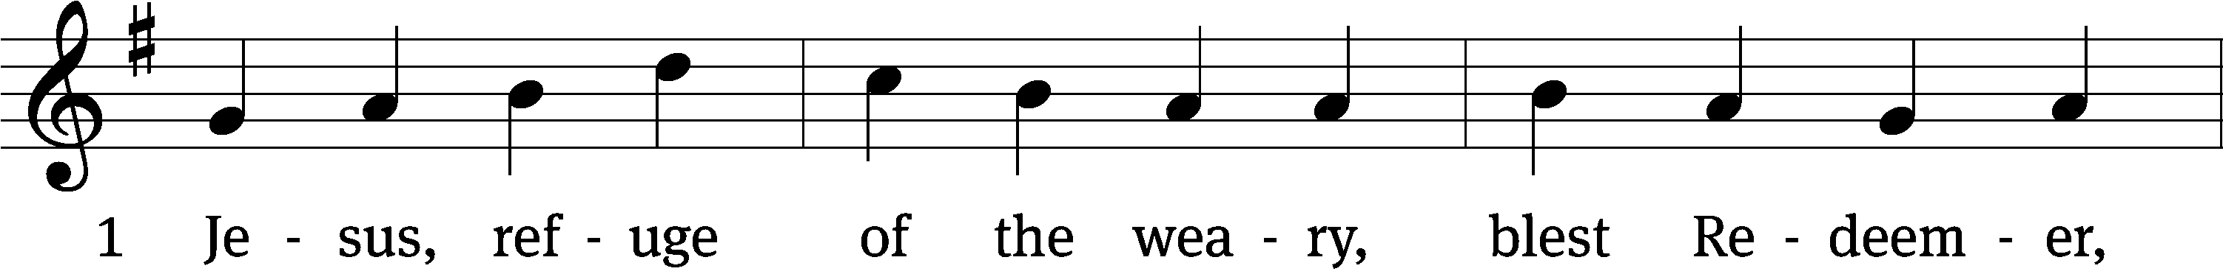
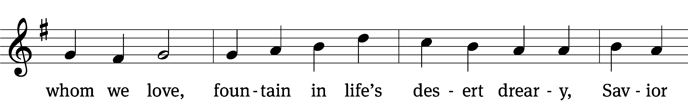
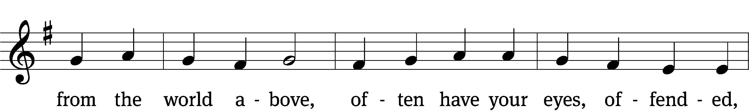
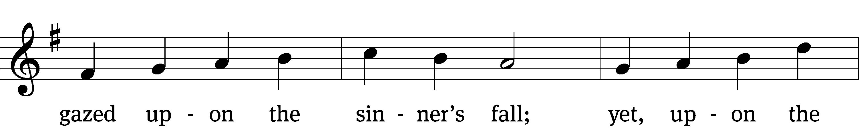
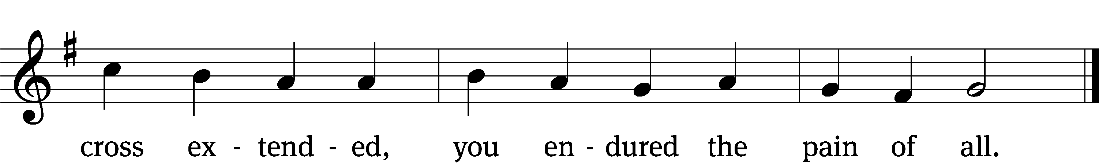
Text: tr. Jane F. Wilde, 1826–1896, alt.; Girolamo Savonarola, 1452–1498
Tune: Erbaulicher Musicalischer Christen-Schatz, Basel, 1745
Text and tune: Public domain

Part Nine
Jesus Before Pilate
11 Meanwhile Jesus stood before the governor, and the governor asked him, “Are you the king of the Jews?”
“You have said so,” Jesus replied.
12 When he was accused by the chief priests and the elders, he gave no answer. 13 Then Pilate asked him, “Don’t you hear the testimony they are bringing against you?” 14 But Jesus made no reply, not even to a single charge—to the great amazement of the governor.
15 Now it was the governor’s custom at the festival to release a prisoner chosen by the crowd. 16 At that time they had a well-known prisoner whose name was Jesus Barabbas. 17 So when the crowd had gathered, Pilate asked them, “Which one do you want me to release to you: Jesus Barabbas, or Jesus who is called the Messiah?” 18 For he knew it was out of self-interest that they had handed Jesus over to him.
19 While Pilate was sitting on the judge’s seat, his wife sent him this message: “Don’t have anything to do with that innocent man, for I have suffered a great deal today in a dream because of him.”
20 But the chief priests and the elders persuaded the crowd to ask for Barabbas and to have Jesus executed.
21 “Which of the two do you want me to release to you?” asked the governor.
“Barabbas,” they answered.
22 “What shall I do, then, with Jesus who is called the Messiah?” Pilate asked.
They all answered, “Crucify him!”
23 “Why? What crime has he committed?” asked Pilate.
But they shouted all the louder, “Crucify him!”
24 When Pilate saw that he was getting nowhere, but that instead an uproar was starting, he took water and washed his hands in front of the crowd. “I am innocent of this man’s blood,” he said. “It is your responsibility!”
25 All the people answered, “His blood is on us and on our children!”
26 Then he released Barabbas to them. But he had Jesus flogged, and handed him over to be crucified.

Hymn CW 397 sts. 1, 3
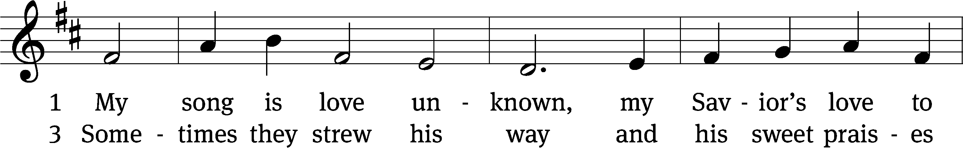
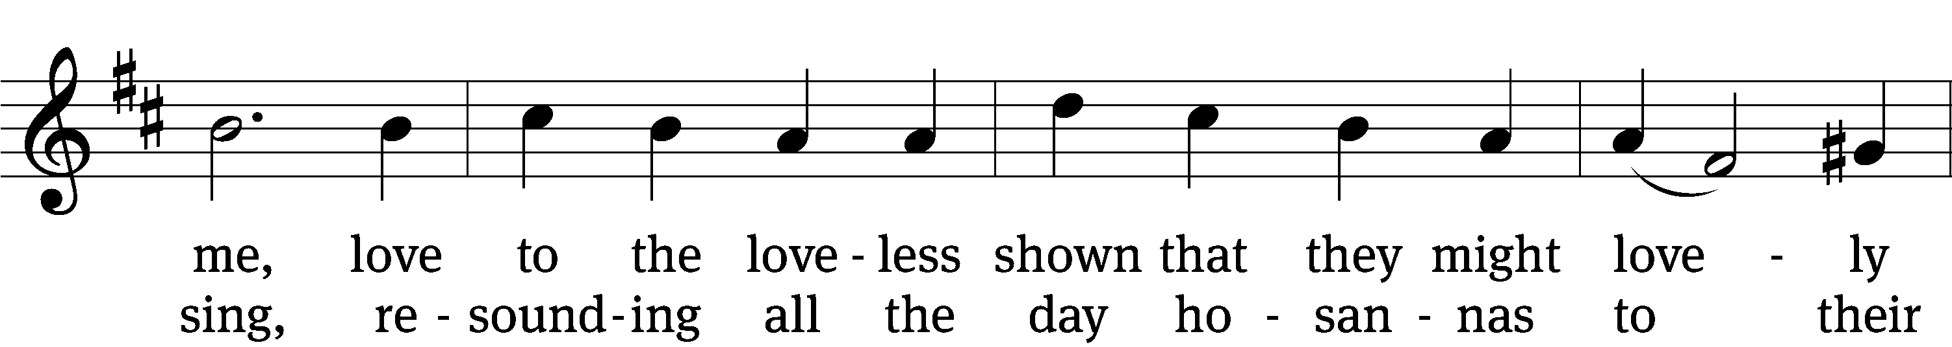
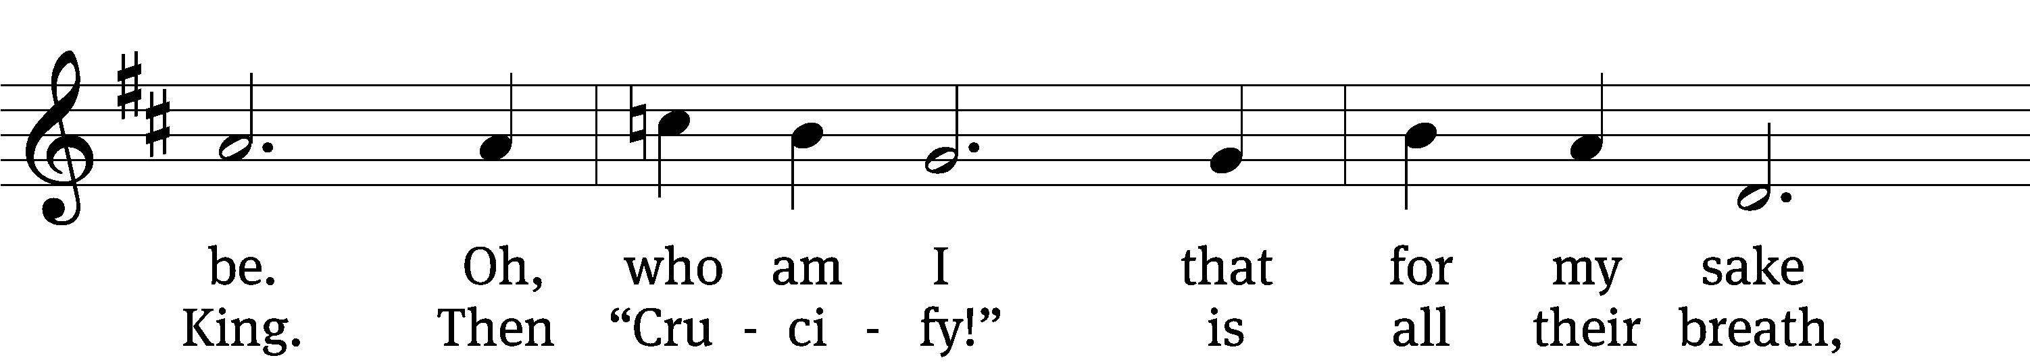
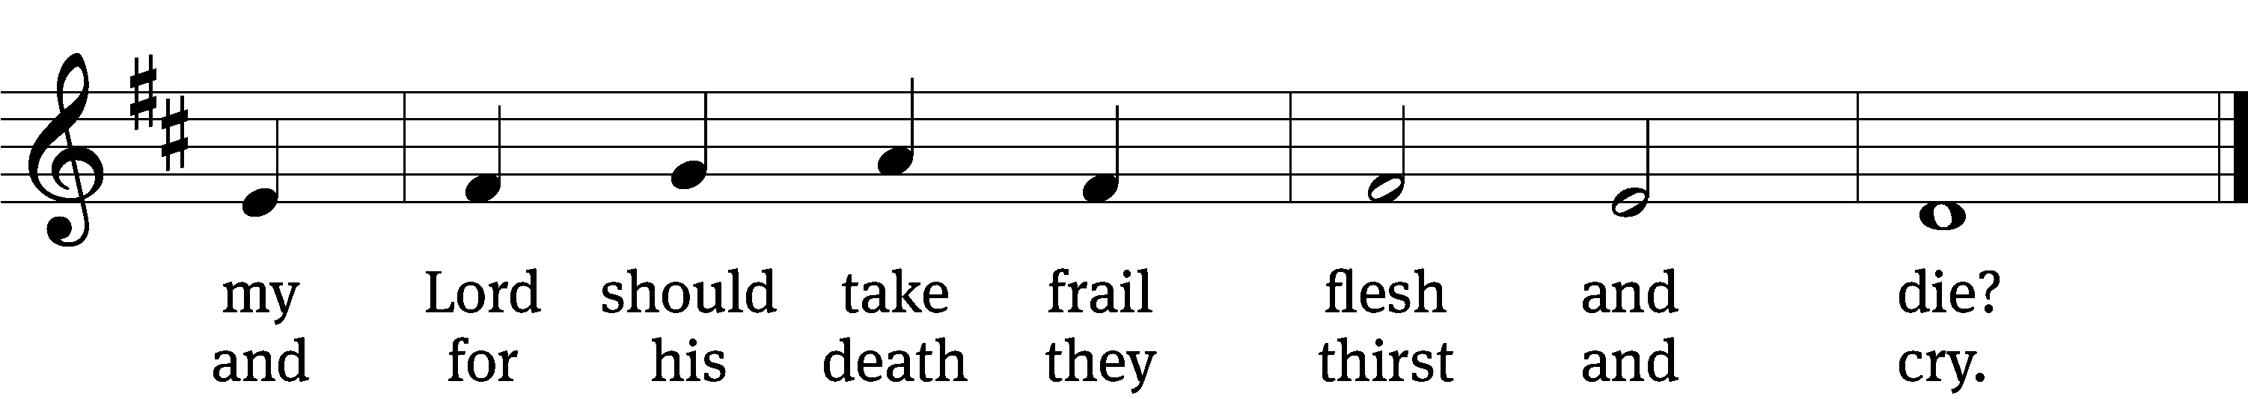
Text: Samuel Crossman, c. 1624–1683, alt.
Tune: John N. Ireland, 1879–1962
Text and tune: Public domain

Part Ten
The Soldiers Mock Jesus
27 Then the governor’s soldiers took Jesus into the Praetorium and gathered the whole company of soldiers around him. 28 They stripped him and put a scarlet robe on him, 29 and then twisted together a crown of thorns and set it on his head. They put a staff in his right hand. Then they knelt in front of him and mocked him. “Hail, king of the Jews!” they said. 30 They spit on him, and took the staff and struck him on the head again and again. 31 After they had mocked him, they took off the robe and put his own clothes on him. Then they led him away to crucify him.

The Crucifixion of Jesus
32 As they were going out, they met a man from Cyrene, named Simon, and they forced him to carry the cross. 33 They came to a place called Golgotha (which means “the place of the skull”). 34 There they offered Jesus wine to drink, mixed with gall; but after tasting it, he refused to drink it. 35 When they had crucified him, they divided up his clothes by casting lots. 36 And sitting down, they kept watch over him there. 37 Above his head they placed the written charge against him: this is jesus, the king of the jews.
38 Two rebels were crucified with him, one on his right and one on his left. 39 Those who passed by hurled insults at him, shaking their heads 40 and saying, “You who are going to destroy the temple and build it in three days, save yourself! Come down from the cross, if you are the Son of God!” 41 In the same way the chief priests, the teachers of the law and the elders mocked him. 42 “He saved others,” they said, “but he can’t save himself! He’s the king of Israel! Let him come down now from the cross, and we will believe in him. 43 He trusts in God. Let God rescue him now if he wants him, for he said, ‘I am the Son of God.’” 44 In the same way the rebels who were crucified with him also heaped insults on him.

Hymn CW 432 sts. 1–2
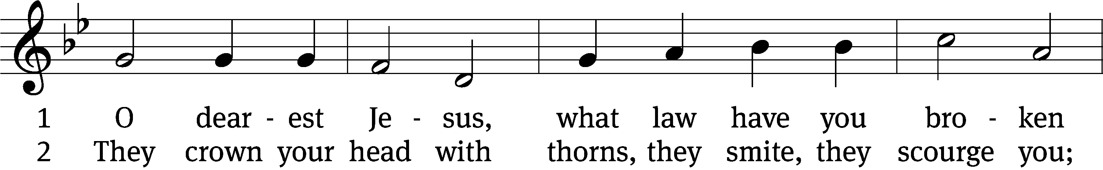
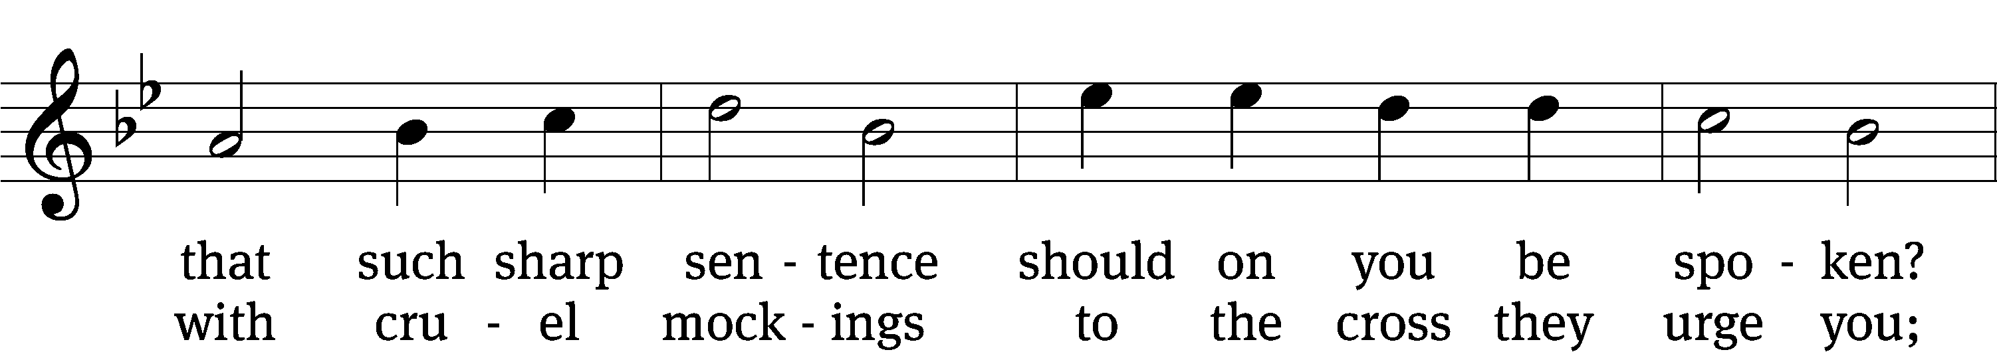
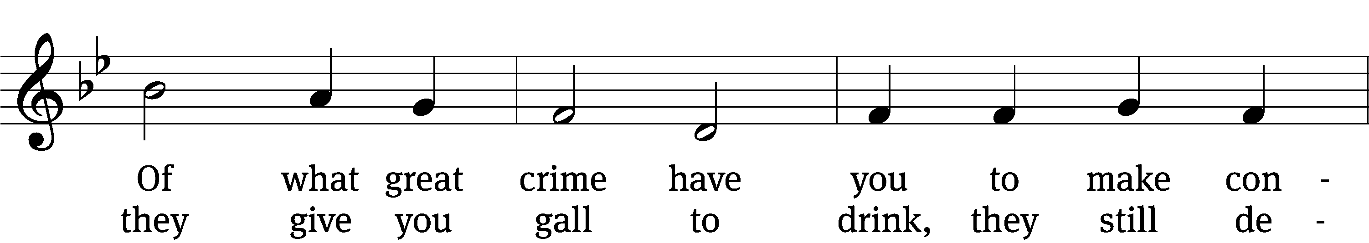
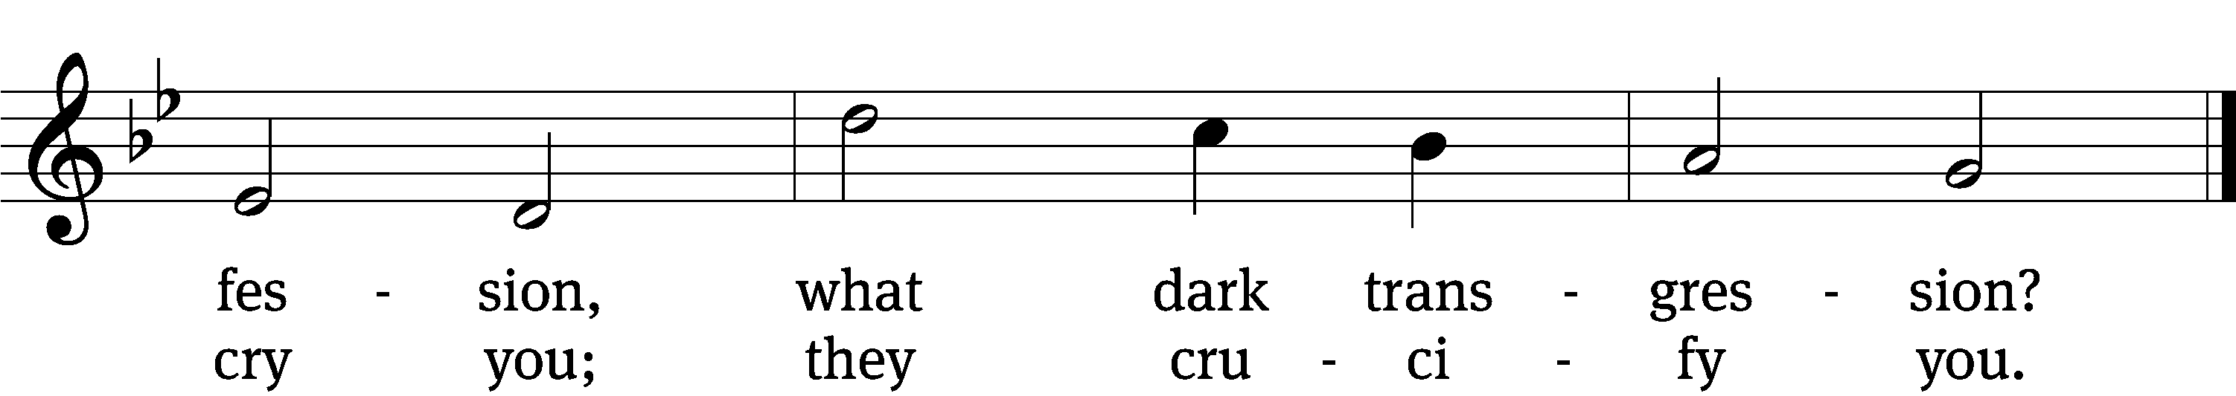
Text: tr. Catherine Winkworth, 1827–1878, alt.; Johann Heermann, 1585–1647
Tune: Johann Crüger, 1598–1662
Text and tune: Public domain

Stand. A moment of silence is observed at the death of Jesus.

Part Eleven
The Death of Jesus
45 From noon until three in the afternoon darkness came over all the land. 46 About three in the afternoon Jesus cried out in a loud voice, “Eli, Eli, lema sabachthani?” (which means “My God, my God, why have you forsaken me?”).
47 When some of those standing there heard this, they said, “He’s calling Elijah.”
48 Immediately one of them ran and got a sponge. He filled it with wine vinegar, put it on a staff, and offered it to Jesus to drink. 49 The rest said, “Now leave him alone. Let’s see if Elijah comes to save him.”
50 And when Jesus had cried out again in a loud voice, he gave up his spirit.

51 At that moment the curtain of the temple was torn in two from top to bottom. The earth shook, the rocks split 52 and the tombs broke open. The bodies of many holy people who had died were raised to life. 53 They came out of the tombs after Jesus’ resurrection and[e] went into the holy city and appeared to many people.
54 When the centurion and those with him who were guarding Jesus saw the earthquake and all that had happened, they were terrified, and exclaimed, “Surely he was the Son of God!”

Hymn CW 429 sts. 3–4
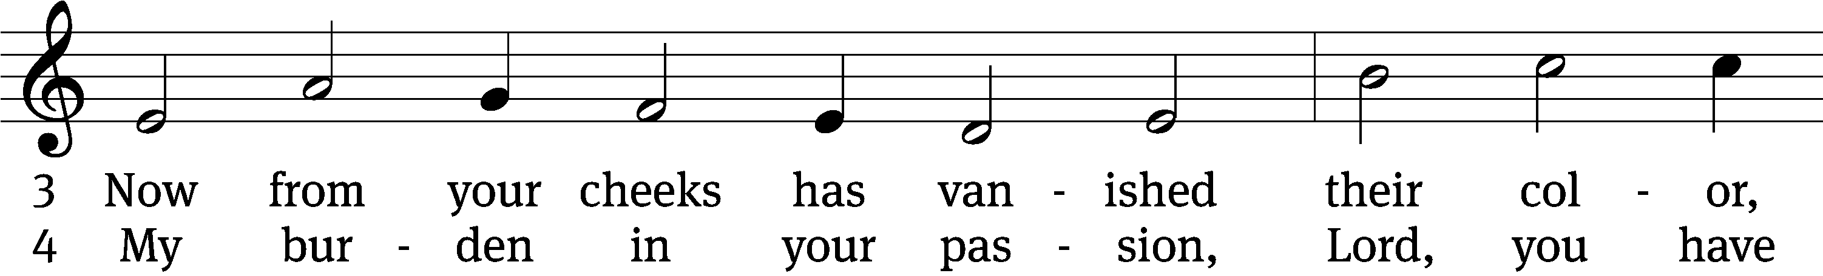

For copyright reasons, the complete hymn is not shown.

Text: tr. The Lutheran Hymnal, 1941, alt.; German version, Paul Gerhardt, 1607–1676; attr. Bernard of Clairvaux, 1091–1153, abr.
Tune: Hans Leo Hassler, 1546–1612
Text: © 1941 Concordia Publishing House. Used by permission: OneLicense no. ######
Tune: Public domain

Be seated

Part Twelve
55 Many women were there, watching from a distance. They had followed Jesus from Galilee to care for his needs. 56 Among them were Mary Magdalene, Mary the mother of James and Joseph, and the mother of Zebedee’s sons.

The Burial of Jesus
57 As evening approached, there came a rich man from Arimathea, named Joseph, who had himself become a disciple of Jesus. 58 Going to Pilate, he asked for Jesus’ body, and Pilate ordered that it be given to him. 59 Joseph took the body, wrapped it in a clean linen cloth, 60 and placed it in his own new tomb that he had cut out of the rock. He rolled a big stone in front of the entrance to the tomb and went away. 61 Mary Magdalene and the other Mary were sitting there opposite the tomb.

The Guard at the Tomb
62 The next day, the one after Preparation Day, the chief priests and the Pharisees went to Pilate. 63 “Sir,” they said, “we remember that while he was still alive that deceiver said, ‘After three days I will rise again.’ 64 So give the order for the tomb to be made secure until the third day. Otherwise, his disciples may come and steal the body and tell the people that he has been raised from the dead. This last deception will be worse than the first.”
65 “Take a guard,” Pilate answered. “Go, make the tomb as secure as you know how.” 66 So they went and made the tomb secure by putting a seal on the stone and posting the guard.

Hymn CW 437 sts. 1–2
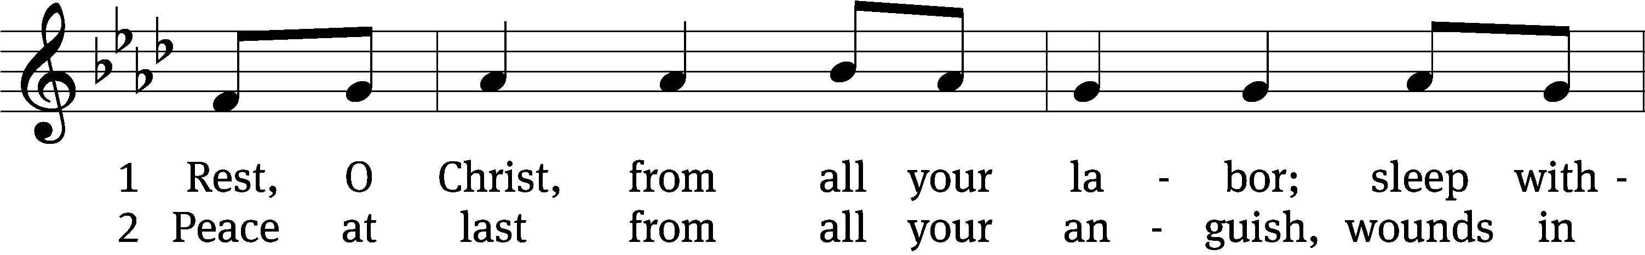
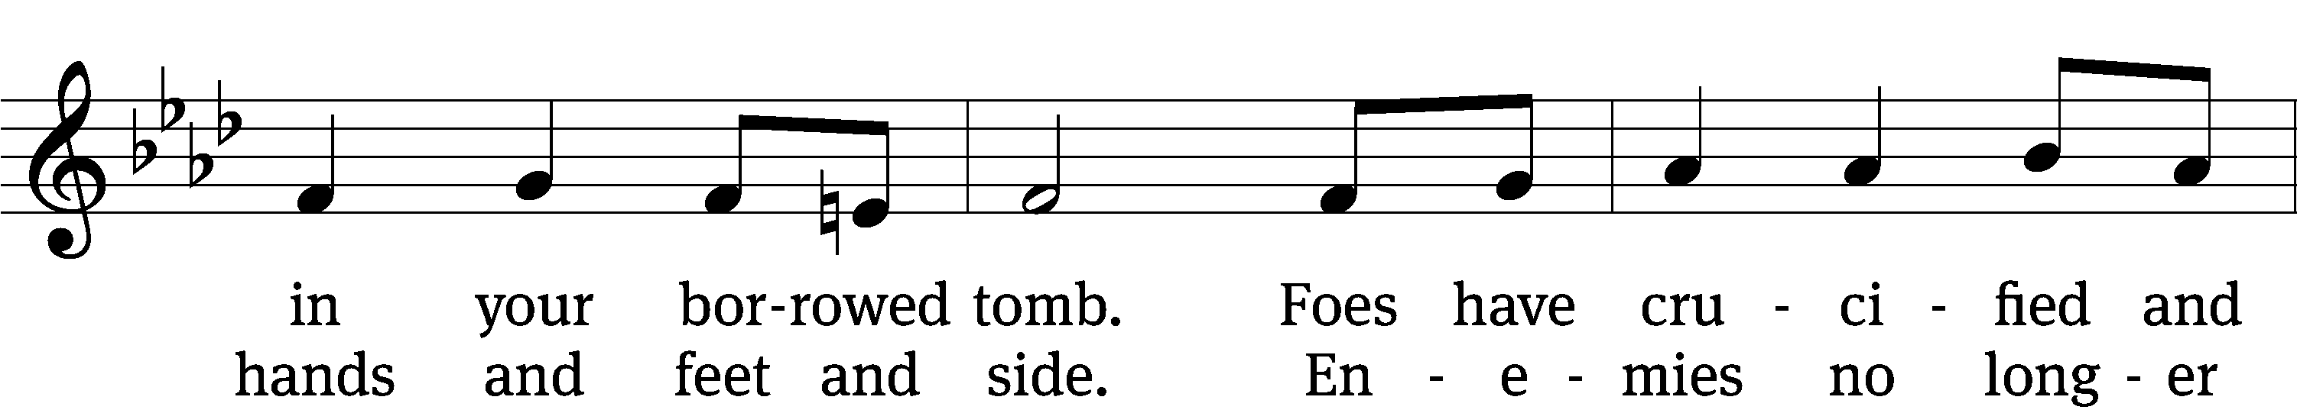
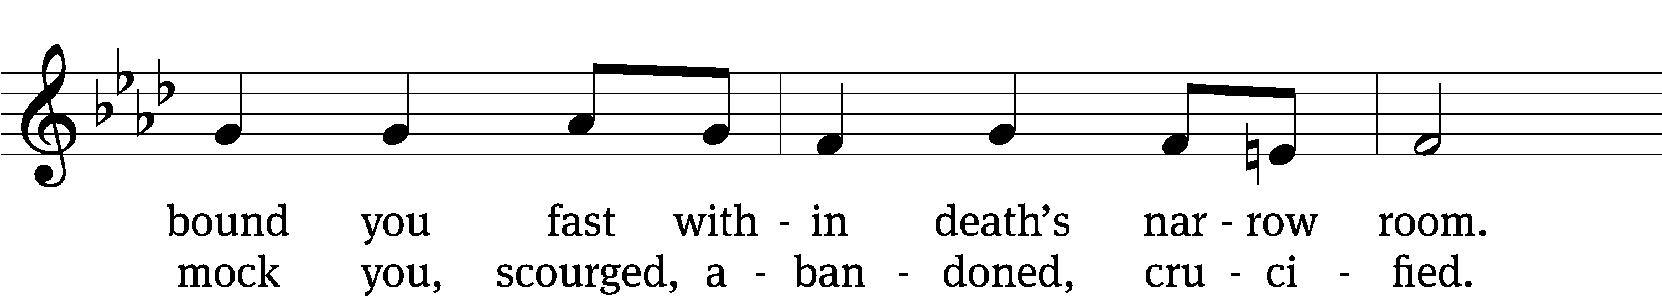

For copyright reasons, the complete hymn is not shown.
Text: Herman G. Stuempfle, Jr., 1923–2007
Tune: Geistliche Volkslieder, Paderborn, 1850
Text: © 1993 GIA Publications, Inc. Used by permission: OneLicense no. 739468
Tune: Public domain

From here on this worship folder only shows placeholders as exported from Service Builder. Those using Service Builder should access files at the links below. Others may customize this draft as needed.

- SB file from My Worship Resources: https://builder.christianworship.com/share/bHFznjyT.
- SB bulletin with hymns inserted: https://builder.christianworship.com/share/V3d10uJJ.

Sermon

Stand

Nicene Creed
We believe in one God, the Father, the Almighty,
maker of heaven and earth,
of all that is,
seen and unseen.

We believe in one Lord, Jesus Christ, the only Son of God,
eternally begotten of the Father,
God from God, Light from Light, true God from true God,
begotten, not made,
of one being with the Father.
Through him all things were made.
For us and for our salvation, he came down from heaven,
was incarnate of the Holy Spirit and the Virgin Mary,
and became truly human.
For our sake he was crucified under Pontius Pilate.
He suffered death and was buried.
On the third day he rose again in accordance with the Scriptures.
He ascended into heaven
and is seated at the right hand of the Father.
He will come again in glory to judge the living and the dead,
and his kingdom will have no end.

We believe in the Holy Spirit,
the Lord, the giver of life,
who proceeds from the Father and the Son,
who in unity with the Father and the Son
is worshiped and glorified,
who has spoken through the prophets.
We believe in one holy Christian and apostolic Church.
We acknowledge one baptism for the forgiveness of sins.
We look for the resurrection of the dead
and the life of the world to come. Amen.

Be seated

Prayer of the Church

Offering

The Sacrament

Stand

Preface CW 165
The Lord be with you.
And also with you.

Lift up your hearts.
We lift them up to the Lord.

Let us give thanks to the Lord our God.
It is right to give him thanks and praise.

Proper Preface
It is truly good and right that we should at all times and in all places give you thanks, O Lord, holy Father, almighty and everlasting God, through Jesus Christ our Lord, who brought the gift of salvation to all people by his death on the tree of the cross so that the devil, who overcame us by a tree, would in turn by a tree be overcome. Therefore, with all the saints on earth and hosts of heaven, we praise your holy name and join their glorious song:

Holy, Holy, Holy CW 167
Holy, holy, holy Lord God of heavenly hosts: heav’n and earth are full of your glory.
Hosanna, hosanna, hosanna in the highest.
Blessed is he, blessed is he, blessed is he who comes in the name of the Lord.
Hosanna, hosanna, hosanna in the highest.

Prayer of Thanksgiving
We give thanks to you, O God, through your dear Son, Jesus Christ, whom you sent to be our Savior, our Redeemer, and the messenger of your grace. Through him you made all things; in him you are well pleased. He is the incarnate Word, conceived by the Holy Spirit and born of the Virgin Mary. To fulfill your promises, he stretched out his hands on the cross and released from eternal death all who believe in you.

As we remember Jesus’ death and resurrection, we thank you that you have gathered us together to receive your Son’s body and blood. Send us your Spirit, unite us as one, and strengthen our faith so that we may praise you in your Son, Jesus Christ. Through him, we glorify and honor you, O God our Father, with the Holy Spirit, one God, now and forever.
Amen.

Lord’s Prayer
Our Father in heaven,
hallowed be your name,
your kingdom come,
your will be done
on earth as in heaven.
Give us today our daily bread.
Forgive us our sins,
as we forgive those
who sin against us.
Lead us not into temptation,
but deliver us from evil.
For the kingdom, the power,
and the glory are yours
now and forever. Amen.

Words of Institution
Our Lord Jesus Christ, on the night he was betrayed, took bread; and when he had given thanks, he broke it and gave it to his disciples, saying, “Take and eat; this is my T body, which is given for you. Do this in remembrance of me.”

Then he took the cup, gave thanks, and gave it to them, saying, “Drink from it, all of you; this is my T blood of the new covenant, which is poured out for you for the forgiveness of sins. Do this, whenever you drink it, in remembrance of me.”

Pax Domini
The peace of the Lord be with you always.
Amen.

O Christ, Lamb of God CW 169
O Christ, Lamb of God, you take away the sin of the world; have mercy on us.
O Christ, Lamb of God, you take away the sin of the world; have mercy on us.
O Christ, Lamb of God, you take away the sin of the world; grant us your peace. Amen.

Be seated

Distribution

Hymn

As he dismisses the communicants, the minister says:

Dismissal
The true body and blood of our Lord Jesus Christ strengthen and preserve you to life everlasting. Go T in peace.
Amen.

Stand

Thanksgiving
Give thanks to the Lord, for he is good;
his mercy endures forever.

Proclamation
Whenever we eat this bread and drink this cup,
we proclaim the Lord’s death until he comes.

Post-Communion Prayer
We give thanks, almighty God, that you have refreshed us with this saving gift. We pray that through it you will strengthen our faith in you and increase our love for one another. We ask this in the name of Jesus Christ our Lord, who lives and reigns with you and the Holy Spirit, one God, now and forever.
Amen.

Blessing
The Lord bless you and keep you.
The Lord make his face shine on you and be gracious to you.
The Lord look on you with favor and T give you peace.
Amen.

Hymn

Acknowledgments
Unless otherwise indicated, Scripture quotations are from The Holy Bible, New International Version®, NIV®. Copyright © 1973, 1978, 1984, 2011 by Biblica, Inc.TM Used by permission of Zondervan. All rights reserved worldwide.
Software distributed in partnership with Northwestern Publishing House.
Created by Christian Worship: Service Builder © 2023 Concordia Publishing House.

