The Festival of the Coming of the Holy Spirit

Welcome!
In the name of Jesus Christ, we welcome you to Gloria Dei Evangelical Lutheran Church! We especially welcome our guests who have joined us today. If you have any questions during your time with us today, please ask an usher for assistance. If you would like to know more about our church, our teachings, our Christian school (grades K-8), or the studies and programs offered at Gloria Dei, please introduce yourself to our pastor. He would be delighted to speak with you and serve you in whatever way he can.

The Lord’s Supper
The Lord’s Supper, will be celebrated in today’s service. The Bible teaches us that Jesus offers us his body and blood for the forgiveness of our sins in the Lord’s Supper. The Bible has also convinced us that receiving the Lord’s Supper together is a public statement of our complete “oneness” in faith.
For this reason, we invite to the Lord’s Supper members of this congregation and guests who are members of sister congregations in the Wisconsin Evangelical Lutheran Synod (WELS) or the Evangelical Lutheran Synod (ELS). If you are a guest from another Lutheran denomination or another Christian Church and would like to commune with us in the future, please speak to our pastor after the service and he would be delighted to explain what that entails. For now, we do not want to be presumptuous and put you in the position of stating your agreement with our beliefs before we have had an opportunity to explain them further. We do look forward to any opportunity to discuss the Christian faith with you.
For more information about our communion practice, please refer to the pamphlet titled “Attending the Lord’s Supper,” which is available in the back of the church.

Information
- The downstairs church fellowship hall is used during our services as a nursery area for parents with small children. The service is broadcast downstairs via closed circuit television for parents who need to quiet their children outside the church sanctuary or for anyone else who may need to leave the service for a time.
- Restrooms are available in the fellowship hall of the church’s lower level. A changing table for infants and toddlers is located in the women’s restroom.
- Personal listening systems are available for anyone who has difficulty hearing the service. Please ask an usher for a personal listening system if you would like to use one.
- Please fill out the blue attendance register after the sermon as the offerings of Gloria Dei’s members are gathered. The ushers will distribute the registers to each at that point in the service.
- Everyone is invited to join after this morning’s service for our coffee hour. Snacks and refreshments will be served.

NOTES ON TODAY’S SERVICE

One of the ways we enhance festival services at Gloria Dei is by incorporating historic Christian worship practices into our services. The church’s ancient worship customs were never commanded or forbidden in God’s Word, but contemporary Christians have often found value in worship forms from the ancient church. These customs can add a sense of dignity and reverence to the service, but most importantly, they are effective and meaningful ways that the gospel can be communicated in a visual manner. As we enter into an increasingly “post-literate” culture where actions speak louder than words and sights can be more powerful than sounds, these visual customs are a useful tool for gospel proclamation. A few of these practices are explained below.

Our festival services often begin with a procession, led with a processional cross. As we see the cross carried through the assembly and into the chancel, it reminds us that we are able to approach God in worship only through Jesus’ sacrifice on the cross for our sins (1 John 2:1-2). The cross is placed next to the lectern, the place where the Scriptures are read and the sermon is preached, as a reminder that “Christ crucified” ought to be the central message of Christian preaching (1 Corinthians 1:23). As the cross is carried out at the conclusion of the service, we are reminded of Jesus’ statement to “take up our cross and follow [him]” in our lives (Mark 8:34).

Since the fifth century, the Christian church has used vestments for those involved in worship. The white robe worn by anyone who assists in the service is known as an alb. The alb is sometimes worn with a cincture, a belt of rope or cloth worn around the waist. The stole is a colored scarf that was worn over the shoulders and reached down to the wearer’s knees or lower. Today the stole is customarily reserved for pastors as a sign of their ordination into the ministry. The chasuble is a sleeveless, poncho-shaped garment that served as a coat or cloak. The chasuble is reserved for services in which Holy Communion is celebrated, and it is worn by the pastor who serves as the presiding minister. (Many Lutheran congregations have reclaimed the use of the alb and stole, but the chasuble has not become as common. For example, at our congregation the alb and stole are regularly worn, but the chasuble is usually worn only for festival services such as today). The stole and chasuble were official garments of the Roman court when Christianity was first legalized in the fifth century. At that time, these items symbolized that the person wearing them represented the government. Christians adopted these vestments as their own once to symbolize that those who serve in the church are also representing a higher Authority. The church’s use of vestments today reminds us of the same principle: Vestments “cover up” the worship leaders to remind us that those who serve us in worship do not represent themselves or preach their own ideas, but they represent Christ and proclaim his message (2 Corinthians 4:5).

THE ORDER OF WORSHIP

PRELUDE

BELL PEAL

Service of the Word

PROCESSIONAL HYMN O Holy Spirit, Enter In

Christian Worship #184

As the hymn is introduced, please stand, face the processional cross in the back of the church, and turn to the front of the church as the cross passes you.

GREETING

Minister: The grace of our Lord  Jesus Christ and the love of God and the fellowship of the Holy Spirit be with you
Congregation: And also with you.

DIALOGUE FOR PENTECOST DAY

M: In the beginning God created the heavens and the earth. Now the earth was formless and empty, and the Spirit of God was hovering over the waters.
C: The Spirit of God has made me; the breath of the Almighty gives me life.

M: Where can I go from your Spirit? Where can I flee from your presence?
C: If I go up to the heavens, you are there; if I make my bed in the depths, you are there.

M: The Lord said, “My Spirit will not contend with man forever.”
C: O Lord, do not rebuke me in your anger or discipline me in your wrath.

M: Be merciful to me, Lord, for I am faint; O Lord, heal me, for my bones are in agony.
C: Turn, O Lord, and deliver me; save me because of your unfailing love.

M: Jesus said to his disciples, “Receive the Holy Spirit. If you forgive anyone his sins, they are forgiven; if you do not forgive them, they are not forgiven.”
C: No one can enter the kingdom of God unless he is born of water and the Spirit. Flesh gives birth to flesh, but the Spirit gives birth to spirit.

M: The Spirit of the Sovereign Lord is on me, because the Lord has anointed me to preach good news to the poor.
C: There is now no condemnation for those who are in Christ Jesus, because through Christ Jesus the law of the Spirit of life set me free from the law of sin and death.

M: Now the Lord is the Spirit, and where the Spirit of the Lord is, there is freedom.
C: Come, Holy Spirit! Fill the hearts of your faithful people, and kindle in us the fire of your love. Alleluia!

HYMN OF PRAISE Glory Be to God in Heaven
Gloria in Excelsis Christian Worship #264

This hymn is a paraphrase of the Gloria in Excelsis, the traditional song of praise sung in Christian churches near the beginning of worship.

PRAYER OF THE DAY

M: Let us pray.
Holy Spirit, God and Lord, come to us this joyful day with your sevenfold gift of grace. Rekindle in our hearts the holy fire of your love that in a true and living faith we may tell abroad the glory of our Savior, Jesus Christ, who lives and reigns with you and the Father, one God, now and forever.
C: Amen.

Please be seated.

FIRST LESSON Joel 2:28-29
Pew Bible, page 1416

PSALM OF THE DAY Selected Verses of Psalm 51

The psalm is printed on the opposite page.

The cantor introduces the refrain once and the congregation repeats the refrain.

The minister and cantor sing the psalm verses.
The congregation sings the refrains and doxology (“Glory be…”).

SECOND LESSON Acts 2:1-21
Pew Bible, page 1692

VERSE OF THE DAY

Alleluia! Come Holy Spirit, fill the hearts of your faithful people, and kindle in us the fire of your love. Alleluia!

Please stand.

GOSPEL John 16:5-11

Pew Bible, page 1678

After the Gospel, the congregation sings:
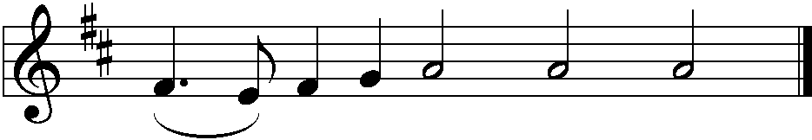
C: Praise be to you, O Christ!

Please be seated.

The setting of Psalm 51b is from Christian Worship: Supplement, © 2008 Northwestern Publishing House.
HYMN OF THE DAY Come, Holy Ghost, God and Lord
Christian Worship #176

SERMON Based on John 16:5-7

Sermon Theme:

You’re (Not) On Your Own!

After the sermon, please stand.

CONFESSION OF FAITH Luther’s Explanation of the Third Article of the

Apostles’ Creed from the Small Catechism

C: I believe that I cannot by my own thinking or choosing believe in Jesus Christ, my Lord, or come to him. But the Holy Spirit has called me by the gospel, enlightened me with his gifts, sanctified and kept me in the true faith. In the same way he calls, gathers, enlightens, and sanctifies the whole Christian church on earth, and keeps it with Jesus Christ in the one true faith. In this Christian church he daily and fully forgives all sins to me and all believers. On the Last Day he will raise me and all the dead and give eternal life to me and all believers in Christ. This is most certainly true.

Be seated.

OFFERING

As the offerings of the members of Gloria Dei are gathered, please fill out the blue attendance register that the ushers will distribute to each pew. Thank you!

Rite of Confirmation

ADDRESS

CONFIRMANDS’ PROFESSION OF FAITH

PRAYER

M: Lord Jesus, author and perfecter of our faith, in mercy you joined these young people to your Church when they were born again of water and the Spirit. In mercy you taught them your saving truth. Grant that they may offer themselves as living sacrifices to you as their spiritual act of worship. Transform them by the renewing of their minds so that they will not conform to the pattern of this world. Help all of us live in love and harmony with one another and to work together in serving you. Keep us united in your Spirit, and bring us at last to your eternal kingdom, where you live and reign with the Father and the Holy Spirit, one God, now and forever.
C: Amen.

Prayer from the confirmation rite in Christian Worship: Occasional Services, © 2004 Northwestern Publishing House.

LORD’S PRAYER

C: Our Father in heaven, hallowed be your name, your kingdom come, your will be done on earth as in heaven. Give us today our daily bread. Forgive us our sins, as we forgive those who sin against us. Lead us not into temptation, but deliver us from evil. For the kingdom, the power, and the glory are yours now and forever. Amen.

BLESSING

DISMISSAL

HYMN Create in Me a Clean Heart, O God
Christian Worship #272
Service of the Sacrament

Please stand.

PREFACE

M: The Lord be with you.
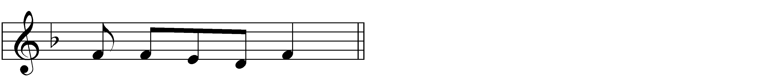
C: And al - so with you.

M: Lift up your hearts.
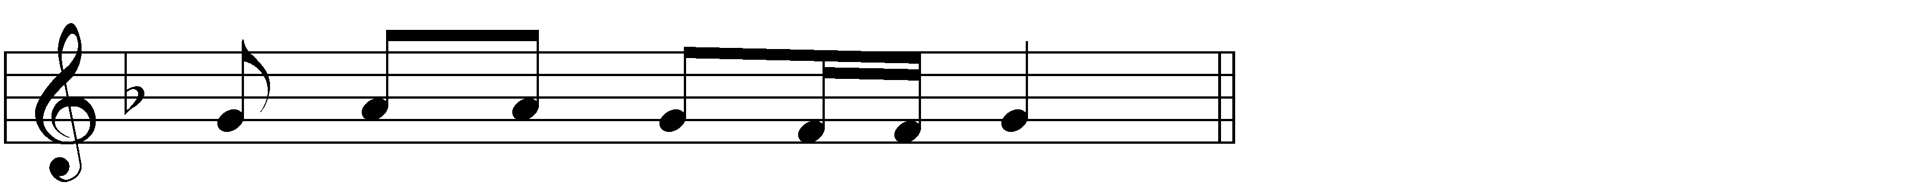
C: We lift them up to the Lord.

M: Let us give thanks to the Lord our God.
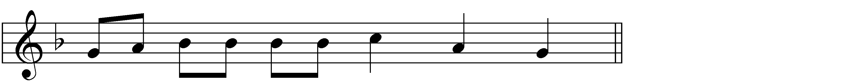
C: It is right to give him thanks and praise.

M: Praise be to the God and Father of our Lord Jesus Christ! In love he has blessed us with every spiritual blessing.
By the outpouring of the Holy Spirit, he empowered his Church to be witnesses of Christ to the ends of the earth.
Now have come the salvation and the power and the kingdom of our God and the authority of his Christ. To him who sits on the throne and to the Lamb be praise and thanks and honor and glory forever and ever.

HOLY, HOLY, HOLY
Sanctus
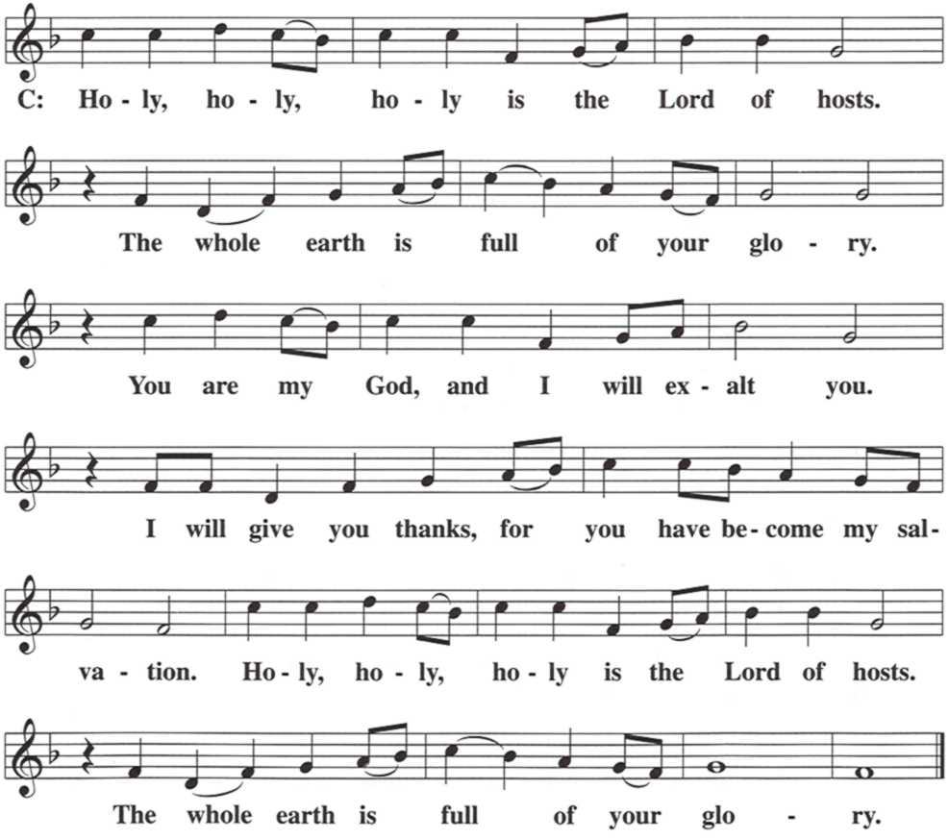

WORDS OF INSTITUTION
M: Our Lord Jesus Christ, on the night he was betrayed, took bread; and when he had given thanks, he broke it and gave it to his disciples, saying, “Take and eat; this is my body, which is given for you. Do this in remembrance of me.”
Then he took the cup, gave thanks, and gave it to them, saying, “Drink from it, all of you; this is my blood of the new covenant, which is poured out for you for the forgiveness of sins. Do this, whenever you drink it, in remembrance of me.”

PEACE OF THE LORD

M: The peace of the Lord be with you always.
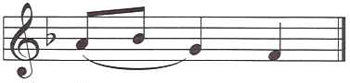
C: A - men.

O CHRIST, LAMB OF GOD
Agnus Dei
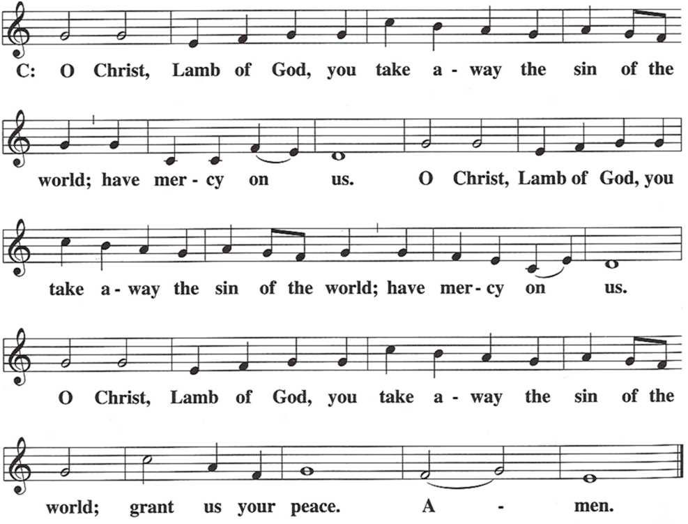

Be seated.

DISTRIBUTION

Members of the congregation and guests from other congregations within our fellowship may come forward at the direction of the ushers. Please refer to the first page of this service folder for an explanation of our communion practice.

DISTRIBUTION HYMN Our Lord and God, Oh, Bless This Day
Christian Worship #599

After the distribution, please stand at the presiding minister’s direction.

THANK THE LORD

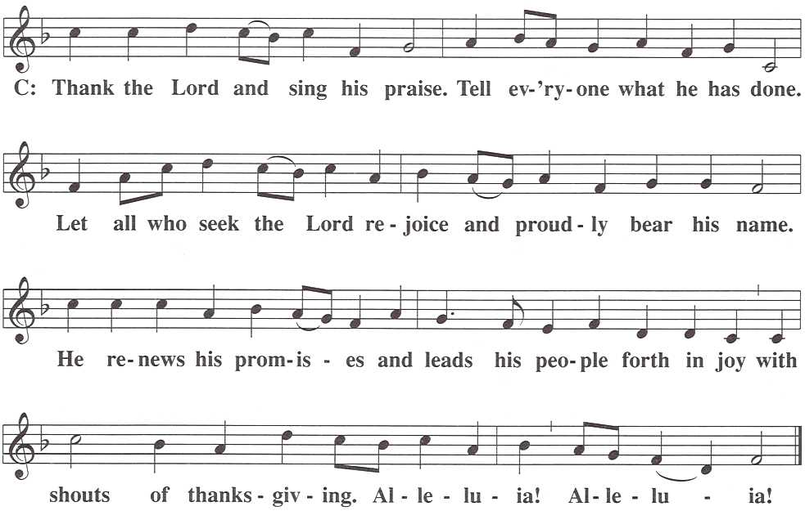

PRAYER

M: Hear the prayer of your people, O Lord, that the lips which have praised you here may glorify you in the world, that the eyes which have seen the coming of your Son may long for his coming again, and that all who have received in his true body and blood the pledge of your forgiveness may be restored to live a new and holy life, through Jesus Christ, our Lord, who lives and reigns with you and the Holy Spirit, one God, now and forever.
C: A - men.

BLESSING

M: Brothers and sisters, go in peace. Live in harmony with one another.
Serve the Lord with gladness.
The Lord bless you and keep you.
The Lord make his face shine on you and be gracious to you.
The Lord look on you with favor and  give you peace.
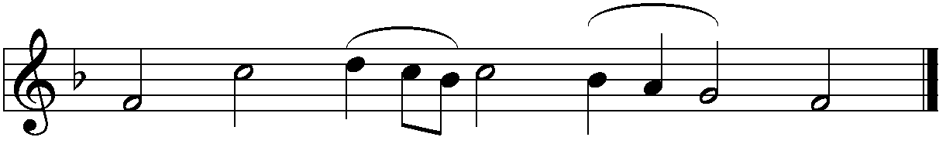
C: A - men. A - men. A - men.

RECESSIONAL HYMN May God the Father of Our Lord
Christian Worship #597

This hymn may be sung in canon (that is, in a round). The second voice enters one measure (four beats) after each stanza begins. The tenor line of the music in the hymnal represents the canon voice. Those who desire to sing the canon are encouraged to do so.

After the hymn, please be seated.

